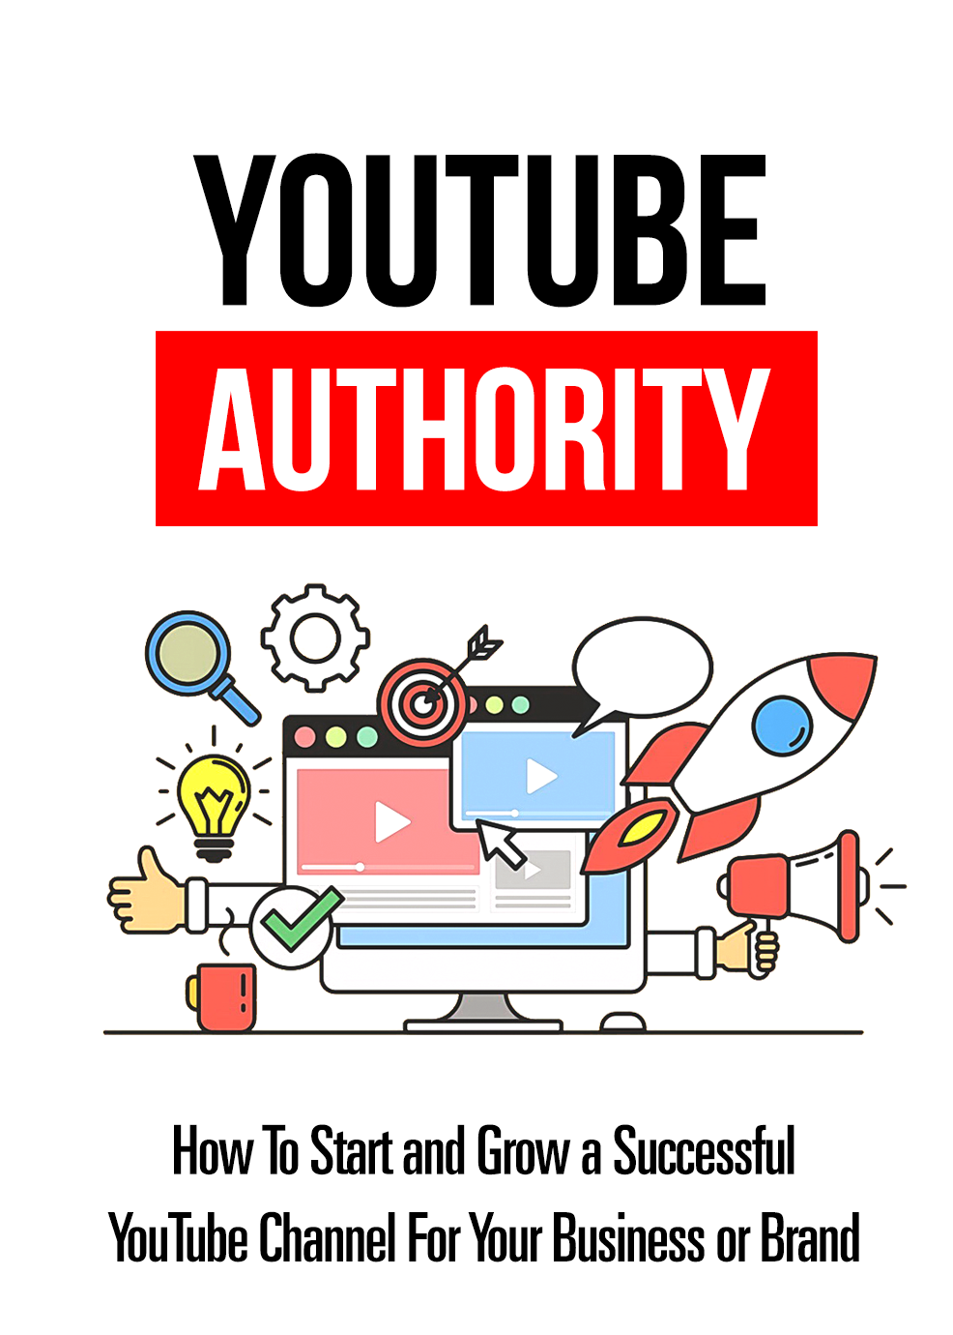
Disclaimer
This e-book has been written for information purposes only. Every effort has been made to make this ebook as complete and accurate as possible. However, there may be mistakes in typography or content. Also, this e-book provides information only up to the publishing date. Therefore, this ebook should be used as a guide - not as the ultimate source.

The purpose of this ebook is to educate. The author and the publisher do not warrant that the information contained in this e-book is fully complete and shall not be responsible for any errors or omissions. The author and publisher shall have neither liability nor responsibility to any person or entity with respect to any loss or damage caused or alleged to be caused directly or indirectly by this ebook.

About the Author

{first_name} {last_name} is an entrepreneur living in {country} who loves sharing knowledge and helping others on the topic of {topic}.
{first_name} is a passionate person who will go the extra mile and over-deliver.
{first_name}'s words of wisdom:
"I believe that knowledge is power. Everyone should improve themselves and/or business, no matter what stage in life they're in. Whether it's to develop a better mindset or to increase profits. Moving forward is key."
If you would like to learn more from {first_name} {last_name}, please visit:
{your URL}

Table of Contents
Introduction 7
Chapter 1 – Getting Started 10
Knowing the Reason Why You’re Starting Your YouTube Channel 11
Determining Your Target Audience 12
Know Your Direct Competition 13
Scheduling Your Uploads 14
Equipment and Software You’ll Need 15
Allocating the Time to Create Your Videos 17
Chapter 2 – Choosing Your Niche 19
Determining What You’re Good At 20
Selecting a Category 21
Researching Topics 22
Consider a “Desperate Niche” 23
Chapter 3 – How to Optimize Your YouTube Channel for Success 25
Choose a Memorable Channel Name 27
Use an Attractive Channel Icon 28
Create a Channel Trailer 29
Integrate Social Media Links 30
Include Channel Art 31
The About Section 32
Chapter 4 – Developing Your Content Strategy 33
Why Consistency is Important 34
Types of Videos You Can Create 34
Vlogs 35
Company Culture Videos 36
Interviews 38
Webinars 39
Events 39
Presentations 40
Tutorials 40
Product Reviews 41
Chapter 5 – Strategies for Building an Audience 43
Comment on Similar Videos 44
Use Social Media 45
Participate in Forums 46
Collaborate with Others 46
Chapter 6 – Strategies for Increasing Your Customer Engagement 48
Create Simple and Beautiful Thumbnails 49
Add Annotations to Drive User Actions 50
Keep Your Videos Short 51
Basic SEO Principles and Marketing Strategies Apply to YouTube 51
Chapter 7 – How to Monetize Your YouTube Channel 53
YouTube Partner Program 54
Affiliate Products 54
Work with Outside YouTube Partners 55
Sell Your Own Merchandise 55
Drive Traffic to Your Website 56
Chapter 8 – Mistakes to Avoid on Your YouTube Channel 57
Purchasing Fake Reviews 58
Doing a Video Dump 58
Ignoring Your Social Media Presence 59
Inconsistent Video Uploads 59
Not Engaging With Your Audience 59
Failing to Have a Plan 60
Trolling Other Channels and Begging for Views 60
Not Linking Your Channel to Your Social Media Accounts 61
Conclusion 62

Introduction

YouTube is currently the world’s most popular video sharing website and has become the second most used search engine after Google. Every month, there are more than a billion users who take advantage of the multimedia giant to watch videos from their favorite YouTubers.

Earning money with YouTube can be an incredibly lucrative method for making money if you are willing to invest the time and effort into this avenue of passive income. While you may have thought that you'd have to strike the viral video jackpot in order to earn any passive income from YouTube, it is entirely feasible to earn a side income that you can gradually build upon. Anyone determined enough can make YouTube a profitable method of income. You have to be willing to invest your time, and you have to have patience if you want to be rewarded with a passive income from YouTube.

YouTube has become a revolution that can no longer be contained. Now more than ever, it is easier to create a video, put it online, and share it with the world. Not only is this great on a personal level, but a professional one as well. While there are other video platforms out there, none has the same reach or profit potential then you can get with YouTube.

A lot of major companies are starting to make their move to establish their presence on YouTube because it is where they can find their target audience these days. In order to make more money, companies are looking to advertise in places where they can reach and engage with more members of their target audience. YouTube provides them with precisely what they need.

YouTube doesn't just benefit large corporations, small businesses and individuals can also make a substantial profit on YouTube, provide they can tap into the power of the video platform and use it effectively. For the majority of people, getting started on YouTube is the most challenging step. Starting a YouTube business channel may seem daunting at first, but with the proper planning and organization, you'll be able to increase your chances of success.

There are specific strategies that you can use to ensure that your target audience is actually watching your videos and that they like the content that you are uploading to your channel. There are different kinds of content that you will want to create, so you will need to identify what works for you and your audience. Building and maintaining an audience is crucial for the survival of your YouTube channel.

Keep in mind that your YouTube channel is for business purposes, so making money is at the core of everything you do.
You need to learn how to monetize your passion and rake in profits by making videos of what you love. It is also important to understand that there is no time better than the present to get started on growing a successful YouTube channel for your business or brand.

Chapter 1 – Getting Started

Deciding to create a YouTube channel for your business is an excellent idea because it can provide you with a broader audience to build brand awareness.

With YouTube, it doesn't matter if you're an experienced business person or a new entrepreneur; you all have the same chance of success. A YouTube business channel provides an equal opportunity for everyone who has something to share with others and who are looking to make money online.

However, there are some things that you must consider before you can set up your account and start creating your first video. You'll need to ask yourself some questions that will help you to examine your overall goals so that you can tailor your approach. You need to start off on the right track if you want your YouTube channel to be a success.

As you consider these questions, take the time to write down the answers you come up with. This can help you see things from a different perspective and can be especially helpful if you find yourself facing challenges down the road. Writing down your thoughts will also show you how far you’ve come when your YouTube channel is up and running.

Knowing the Reason Why You’re Starting Your YouTube Channel
No other factor in this process requires as much thought as this one. You have to understand why you feel like you need to establish a presence on YouTube. It is essential that you know what precisely your business is looking to accomplish and whether other video platforms can be used to achieve success. These are things that you have to consider before you dive feet first into creating videos to publish on YouTube.

Maybe you are passionate about fitness and want to make some money teaching people how to get in shape. You might already have a personal website and want to generate more traffic. Maybe you're an expert at something and want to produce educational content in exchange for a fee. You could use your YouTube channel to advertise new and existing products to a broader and more diverse audience. These are just a few reasons why you might want to start a YouTube channel for your business.

On the flip side, you may be thinking that you just want to make a lot of money, so you never have to work again. If this is what you're thinking, then you will probably want to take some time to think things through. While a lot of people have become rich and famous off of a single video they uploaded to YouTube, it was nothing more than luck. They probably never thought they could achieve success with a single, random video. There is a lot of time and energy that goes into starting and maintaining a YouTube business channel. The secret to achieving success is doing things right and doing it often.

Determining Your Target Audience
Now that you know why you want to create a YouTube business channel, it's time to consider the audience that you want to target. This is the step in the process that you need to develop an audience persona profile. It can help considerably if you can get more information about your target audience, including their age, gender, social status, geographical location, and preferences. If you want to make money, you can't merely go gung-ho and try to make videos tailored to everyone. You will never be able to please everyone, so it is essential that you know the type of people who will appreciate your content and who will choose to become loyal fans. If you cater to their specific content needs, they will be more willing to pay you for your efforts.

Know Your Direct Competition
YouTube is a massive platform, so you'll want to expect some stiff competition in the niche that you choose. You need to take the time to check on whether or not there are other YouTube channels that also serve your potential audience. You can type the keyword for your niche into the search box and look at the other channels that are offering similar content.

You want to ask yourself how you will set your YouTube channel apart from the competition and what you will do differently. After doing some research, you'll be better equipped to distinguish yourself by offering what your competitors aren't. In other words, you want to give your audience a reason to subscribe to your channel instead of the competition. Keep in mind that just because a specific niche has a lot of competition, doesn't mean that you can't dive into it. Figure out how you can stand out from the crowd, and you'll find success.

Scheduling Your Uploads
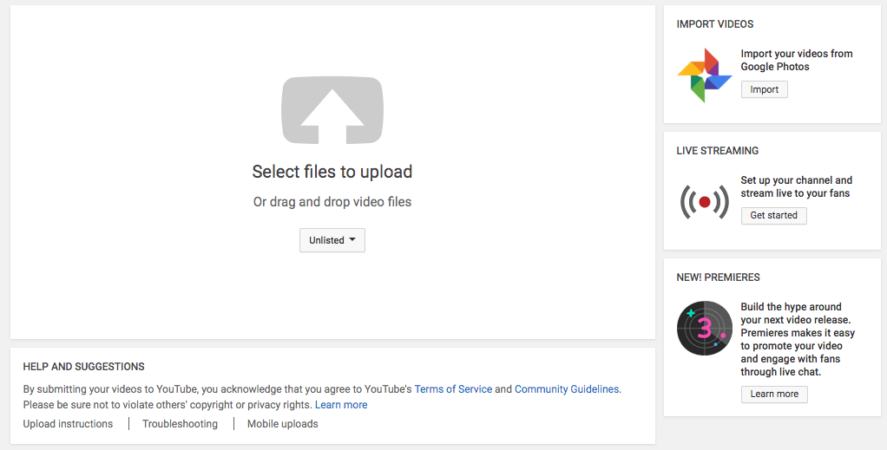
If you want to establish a strong presence on YouTube and find success, then you have to make sure you are uploading videos regularly. Your channel has to have up-to-date content so that you are always on the mind of your subscribers.

Think about how often you want to upload a new video and take into account factors like the length of time it takes you to create a video. In an ideal situation, you will have enough time to make a good quality video and upload it according to your schedule. However, you don't want to have too long of an interval between your uploads because online audiences can be extremely fickle and can forget about you quickly. The best option is to find a balance that will suit both your hectic schedule and your audience.

Equipment and Software You’ll Need
You may think that you will have to go out and buy a bunch of expensive camera equipment, like a camera and lens or lighting, but you probably have all the stuff you need already.

These days most smartphones come with a high definition camera, and most laptop computers come with inexpensive webcams that can be used for creating high-quality videos. When it comes to lighting, all you need is to place a few lamps strategically around the room to provide you with light that looks professional.
Doing a simple search for “photography lighting” on Amazon or eBay will bring you hundreds of options for lighting.
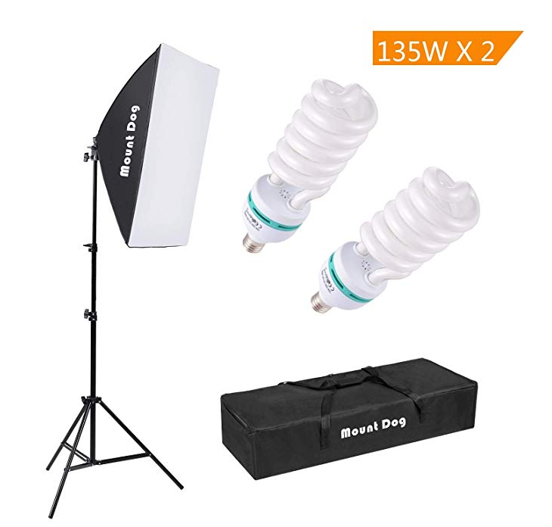
These days you don't have to spend an arm and a leg on producing high-quality videos for your YouTube channel.

One thing that you do need to consider is the editing software that you are going to use. There are plenty of options on the market that will fit your requirements, and that won't break your budget. Do some research to determine which editing software that will be easy for you to use and that will fit in your budget.

Here are a few options:
- Apple iMovie – For Mac users only. This is a free tool that is usually included with your Mac.
- Movie Maker – A free video editing tool for Windows users.
- Final Cut Pro X – A more advanced video editing tool which does require you to pay for use.
- Adobe Premier Pro – Another advanced video editing tool which requires payment for use.

Choosing your equipment and editing software are important decisions that you should make before you get started.

Allocating the Time to Create Your Videos
It takes a lot to make a YouTube channel successful. It isn’t just about making a single video and moving on. You also have to spend the time to promote the channel through social media, grow your subscriber list, and engage with your audience. You need to take the time to sit down and figure out how much time you can actually allocate for building your channel and then break it down according to the necessary activities. It is essential to give each activity its due time since they are all linked. If you focus too much time on making your videos and not enough time promoting them and engaging with your audience, it will eventually cost you.

Getting started on YouTube takes a solid understanding of what it takes and a detailed plan for initiating and maintaining the channel. Taking the time beforehand will ensure you are given the best opportunity to succeed.

Chapter 2 – Choosing Your Niche

By selecting a niche for your YouTube channel, you are one step closer to standing out from the sea of YouTube channels. When someone finds the channel that has the content they are looking for, they will likely view the other videos on the channel, and they may even subscribe to the channel to keep up-to-date with the new content published.

Choosing a niche is not only essential but can also be a difficult decision as well. It is always optimal to start off on the right foot, and selecting the niche for your channel is a long term decision. Even after you have chosen your niche, you will still need to drill down to specific topics. It is essential that you choose a niche that you not only enjoy but one that you are good at, as well as choosing a niche that is in demand.

Determining What You’re Good At
This is one of the most common methods for selecting a niche. This is the time to utilize your strengths. Take a look at your hobbies and what you like to do for fun. Perhaps you excel at playing video games, and you want to create videos showcasing your gaming prowess. Maybe you are a fitness buff and want to share your knowledge by creating how-to-videos on health and fitness. Whatever the case, you can convert your current skills into quality, compelling videos that people will want to watch.

A fundamental method for narrowing down your niche is determining whether you are looking to entertain or inform your target audience. It is also important to decide how long you want your videos to be. Addressing just a few factors will help you in choosing your niche. Even after you have selected your niche, you will still need to determine if there is enough demand for it, to avoid wasting time and effort. You want to make sure to choose a niche where you are not only confident in your skills, but also that there is enough of a market.

Selecting a Category
There are several categories in YouTube that you will need to consider. With such a massive collection of videos in their storage, YouTube has no choice but to classify those videos. When you start to review the categories, you want to try to imagine the kinds of videos that are commonly seen in each group. There are 15 different categories that YouTube's library of videos are broken into and include:

- Comedy
- Autos and Vehicles
- Entertainment
- Education
- Film & Animation
- How-to and Style
- Gaming
- Music
- Nonprofits and Activism
- News and Politics
- Pets and Animals
- People and Blogs
- Science and Technology
- Travel and Events
- Sports

These categories, at first glance, may appear only to be useful for searching through the millions of videos in YouTube’s library. However, take some time to look at the categories and consider what it would be like to pursue each topic individually, which can be an insightful practice for finding your niche.

Researching Topics
Figure out what the most popular topics are today. You can do this by signing up for Google Ads Keyword Planner (https://ads.google.com/home/tools/keyword-planner/). Once you’ve determined your niche, you will need to figure out the most common problems or questions that people within the particular niche face. This is what you can base your videos off of, by solving those issues or problems with the videos you create. For example, many people are interested in learning about new technology and its future. If you are interested in the technology niche and want to delve into it, you can create videos that discuss the latest gadgets and prospective electronics. If you are already an affiliate, it would be strategic for you to implement a brief promotion for an affiliate product relative to the niche at the end of each video.

All that is required is to find a large enough market that is willing to spend money. After that, it comes down to drilling down to a specific niche and creating content that is relevant and that either solves a problem, serves to inform them, or entertains them.

Consider a “Desperate Niche”
If you are still having trouble choosing a niche, you may want to consider what is known as a desperate niche. When someone is in dire need of a solution to their problem, they are more likely to spend money. When people spend excessive cash to get rid of their problems, a desperate niche can often be a profitable source of income. If you notice an issue that people are desperately trying to rectify, this is an excellent example of a desperate niche. This is your opportunity to help them through well-constructed YouTube videos and make a profit.

However, you need to remember that even with a desperate niche, you have to enjoy the topic, or at the very least have an interest in it, or you will eventually grow tired of it and give up. For instance, if you never had a problem with your weight, you will most likely not be very passionate about starting a channel that is dedicated to weight loss. You need to ensure that your content offers value and isn’t just an attempt to milk the viewers out of their money, or you won’t get the results you want in the long run.

Determining your niche is an essential first step in creating a successful YouTube channel. Remember, you must choose a subject that you are, at the very least interested in, to ensure you'll stick with it in the long run.

Chapter 3 – How to Optimize Your YouTube Channel for Success

In order to make the most of your YouTube channel, there are a few things that you will need to utilize. Too many YouTubers make the mistake of neglecting their channel because they are too focused on making the videos.

You have to think of your channel as another landing page, just like your company website. If you want people to continue to come back to your channel, then you have to consider your channel page, as the experience is what entices viewers to come back to your channel and subscribe.

Like any other website, you will need to take the time to craft your channel’s page to make it appear professional and entice viewers to return for more. Many of the elements are what drive the success and appeal behind your channel. The most successful channels commonly employ these elements because they work.

To boost your exposure, you will need to spend some time to configure your YouTube channel properly. If you follow these tips, your channel will begin to generate a good amount of traffic.

Choose a Memorable Channel Name
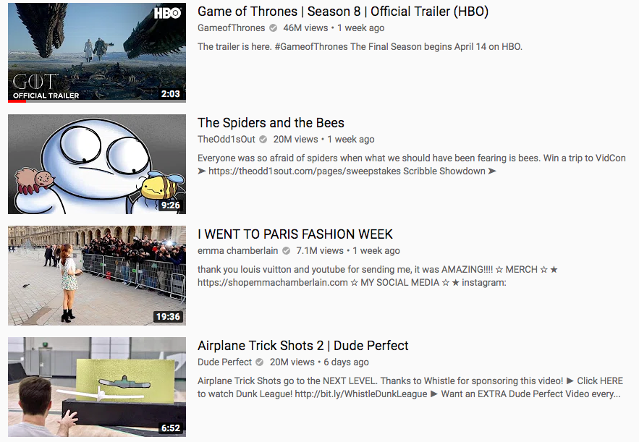
Giving your channel an appropriate name will make all the difference in viewer memorability. If your channel name is short and catchy, people will have no trouble remembering your username and searching for you. However, if it is long and uses numbers, your username will not likely be remembered by your target audience. Your username should not only reflect who you are but also what your channel is about. For example, if you are creating a fitness channel, your name could include a fitness related term. If you intend to create a music channel, you might want to consider incorporating a musically related term for your channel name. However, you need to remember that different niches will call for different username styles. Invest some time into this step, as your name is going to represent who you are in the YouTube community.

Use an Attractive Channel Icon
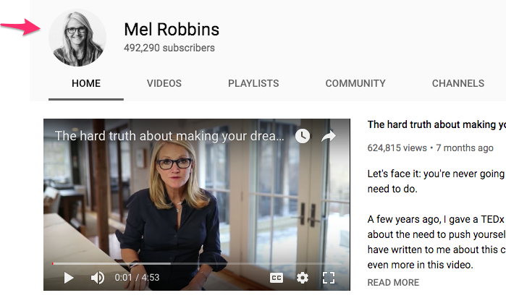
The channel icon is your profile picture that appears next to your channel name, and you should upload a clear image that looks attractive at smaller resolutions. When visitors watch videos on your channel, your channel icon is one of the first things that they will see and could be what provokes them to visit your channel in the first place. If your icon is dull or relatively unattractive, it could turn viewers off and negatively impact your channel's traffic. Your channel icon is also what will help to establish the brand of your YouTube channel. By keeping this somewhat consistent with your channel header, it will help to reinforce your channel's branding.

Create a Channel Trailer
A great way to welcome an unsubscribed viewer is to create a video that showcases what your channel is all about. A channel trailer, when done correctly, can entice new viewers to check out more of your content. You want to try to hook your visitors as soon as they land on your page, and the best way to do this is with a channel trailer. This short video will tell your viewers who you are and show them what they can expect to find on your channel and can be used to convert viewers into subscribers. Your channel trailer needs to be compelling and persuade viewers to see what else your channel has to offer.

Your channel trailer is basically a quick marketing medium for your channel and should last for no more than two minutes. Make sure that you have a way to invite the viewers to subscribe to your channel at the end of the trailer, since the viewers who watch until the end of the trailer or more likely to subscribe.

Integrate Social Media Links
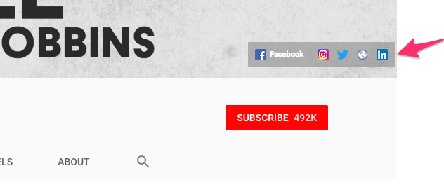
YouTube provides you with the ability to add your social networking links to your channel header.

Every single successful channel on YouTube does this and is highly recommended because it will help you build your network. People who are curious enough to view your channel are likely going to be intrigued enough to interact with you via your social networking accounts, or at the very least follow you on social media. You can maximize your exposure by integrating your social media links on your YouTube channel.

By redirecting people from your channel to your social media, your social networking power will grow. Some of those who you originally brought from your channel will tell others about you and further expand the exposure for your brand.

Include Channel Art
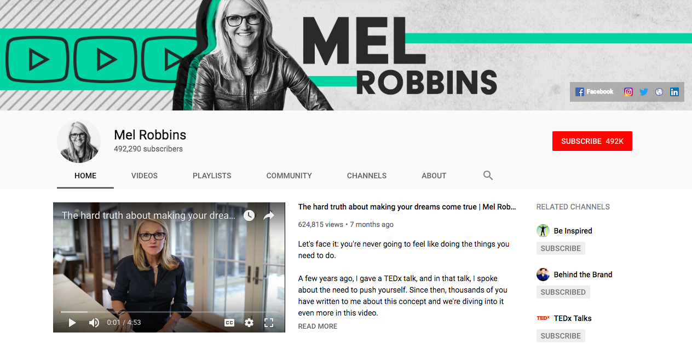
The channel art is the header image at the top of your channel and is the ideal place for you to incorporate your logo. With channel art, anything goes, as long as you don't settle for one of YouTube's default backgrounds. First impressions matter, as the channel header is one of the first things that viewers will see. Incorporating a custom header will give your channel a unique look and atmosphere. Having a generic header background will only indicate to the viewers that your channel isn't high quality, and they will most likely pass it by. When you create an appealing background header, can help potential subscribers see what else you have to offer. Take the time to design your channel art that will leave a lasting impression on your first-time viewers and will get people wanting to return to your channel time and again.

The About Section
It can never hurt to include a brief, concise description detailing what your channel is all about and who you are under the about section. Many favorite channels are in the habit of including their professional emails in the description for business inquiries and is something you should consider doing. You also want to include your social media links as well. If your viewers didn't click on them under channel heading, then they might do so upon a second appearance under your about section. It is also important to include relevant keywords in your about section to make your channel search friendly.

Optimizing your channel is an easy way to help your channel stand out from the crowd. Taking the time to ensure you have a unique YouTube channel can help you get more views, convert more subscribers, and grow a successful YouTube channel for your business.

Chapter 4 – Developing Your Content Strategy
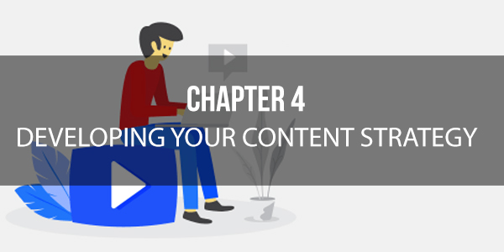
If you want your YouTube channel to be successful, then you need to develop a content strategy that includes how often you are going to post, as well as what kind of content you’re going to post. It's a good idea to have set days where you post new material because it creates a sense of anticipation for your subscribers. It can also help to keep you on track by providing you with a deadline for filming, editing, and posting new content.

Why Consistency is Important
The consistency of content is incredibly important if you want to grow a successful YouTube channel for your brand. While you won't be able to satisfy everyone, you must satisfy your target audience. Switching topics and focus will only confuse your viewers and result in fewer subscriptions to your channel. Only YouTubers who have a reality show style channel or you have gained credibility and respect over time can get away with producing videos on a range of topics.

If you have a fitness channel, you may decide to upload cooking videos showing viewers how to make healthy dishes on Mondays, training videos on Wednesdays, and update videos on Fridays. Whatever you choose to do, the important thing is to remain consistent.

Types of Videos You Can Create
One of the reasons why many businesses have yet to jump on the video marketing train is because they feel they lack creativity. Many smaller companies and entrepreneurs see articles and blog posts as the safe choice and much easier to manage. It may seem like it is much easier to write about a different topic each week, then it is to create a new and unique video every week. However, it doesn't have to be as hard as you think. There are a number of useful types of video content that your YouTube viewers will enjoy and that will help to separate you from the competition.

Vlogs

Video blogs or vlogs are easy to produce, won't cost you a ton of money to make, and are personality-driven, which can substantially increase your engagement with your audience. However, few companies are taking advantage of this unique content idea. More companies are choosing, instead, to spend their money on product demos and polished business intro videos. While there is nothing wrong with taking this approach, vlogs are much cheaper to produce and can be created in as little as five minutes.

More and more businesses are embracing vlogging, so instead of trying to come up with new content every week, you could try documenting your journey through a vlog. Vlogging is a great medium to share your journey because of its intimacy and how easy it is to build a relationship with your target audience.

Company Culture Videos
Company culture videos can make your business seem more human and more alive, and there is no better medium for tapping into this human element than videos. Culture videos can include birthday parties, pranks, slice-of-life employee interviews, and everything in between. The goal is to show your target audience that your business isn't just clockwork, but a social fabric with a ton of personality.

These days it can be hard for businesses to create unique and compelling content that cuts through the online noise. At some level, you will end up just regurgitating material that is already out there. The only way your company can truly stand out and be unique is by differentiating yourself through your personality, and the easiest way to do this is to lift the veil and provide your viewers with a behind the scenes look and what goes on in your company.

Interviews

One of the best ways to become a thought leader in your industry is by interviewing other thought leaders. Video interviews are a great way to insert some authority into your library of engaging and humorous offerings. They can also help to build relationships with potential referral partners, which can't hurt. Video interviews can be an easy way to produce content quickly and gain a positive brand association by interviewing well-known guests.

Webinars
One of the most valuable offerings you can give your viewers is webinars. Webinars are high-value and low-cost endeavors that require no scripts or actors. You can host Q&A sessions with clients, product demos with participating customers, or roundtable interviews with thought leaders in your industry. Webinars are also great pieces of content that you can promote through paid traffic. They can be incredibly useful gateways to your other content, where you can drive leads to a consultation call or sell them another product through an email series.

Events
An event video is a step up from a webinar and covers the proceedings of a corporate event, in a polished and highly shareable manner. Traditionally, event videos take a lot more to produce than other kinds of videos, but with the popularity of 15-second Instagrams and Facebook videos, more companies are beginning to capture snippets of their events in a montage form. Event videos bring the excitement of the event to viewers who couldn’t make it to the party. A great event video will increase your online presence.

Presentations
A presentation video takes the excitement of an event and combines it with the usefulness of a webinar. They can create a compelling and shareable narrative that will help you stand out from the crowd. One way you can use the excitement of presentations to your advantage is by providing a targeted presentation at a company event or at smaller-scale networking events.

Tutorials
Providing your audience with helpful content has to reach further than simple promotional tie-ins and soft selling because your target audience is smart enough to know when they are being sold, and it is never something that they like. Consider providing video tutorials that focus on helping your audience. For example, if you are a tech company, you might want to consider focusing on creating product tutorials, or if you are a health and wellness video, you could produce training videos that offer viewers helpful workout tips. You have to think of a way that you can provide an actionable resource that is relevant to your target vertical.

Product Reviews
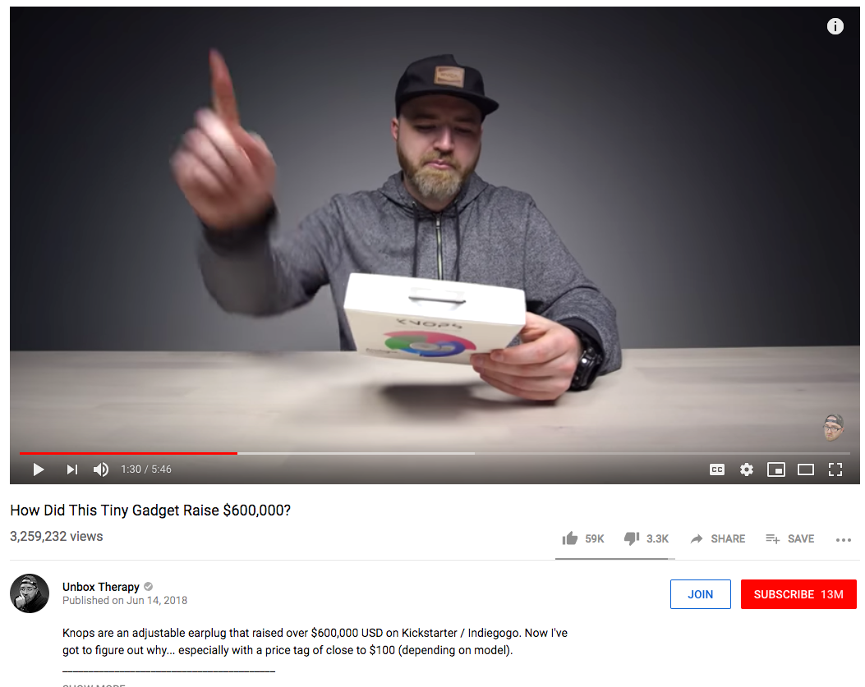
If you have an audience that trusts you, you can review products that they might find useful. The product reviews don't have to be reviews of competitors products, but instead, they can be reviews of products not in your industry that you believe will be useful for your customers. You just need to think of products that you trust and that you feel will help your customers in some way.

Choosing the types of videos that you will produce is almost just as important as the content that you are sharing with your viewer. Creating different types of videos that focus on the same topic can be a great way to keep your viewers from getting bored with your channel.

Chapter 5 – Strategies for Building an Audience

Getting noticed on YouTube is getting more difficult because of the perpetually expanding library of videos. If you are trying to gain new subscribers and broaden your exposure, then you have to do more than merely upload a video. No matter how great your videos are, you have to do more if you want them to garner the attention they deserve.

Unfortunately, there is no secret trick to boost your subscriber base magically. If you're going to gain adequate exposure, then you have to put in the time and effort to reach your target audience and gain more subscribers. You will need to utilize a variety of marketing strategies if you want to get the word out about your channel and draw people in. While it will take some time, your audience will gradually increase.

For maximum exposure, you'll need to promote your channel through as many methods as possible so that you can establish a powerful online presence. This can be challenging, but with the following strategies you can build your audience and grow your business channel on YouTube.

Comment on Similar Videos
This isn't to say that you should be spamming other YouTube channels with self-promoting comments. Instead, you want to try to leave comments of value or insightful feedback on favorite videos that are relevant to your business. Leaving comments on videos that are in the same niche as yours will open your channel up to new viewers that may be more inclined to see what your channel has to offer. When your top comment is one of the first that viewers see, it can provide you with great exposure for your channel and may induce others to explore and perhaps even subscribe to your channel. If you are well known enough, some of your fans may stumble across your comment and reply back. This happens more often than you might think and small channels usually take advantage of this on popular competitors' videos to gain more exposure.

Use Social Media
If you haven't already set up your accounts for your YouTube channel through the other major social media networks, you need to do this immediately. There is not a single successful channel on YouTube that doesn't integrate at least one of their social media accounts with their channel.

Social media is essential for reaching a broader audience and marketing your videos. It is one of the only ways that you can establish your online presence and advertise your channel. There is a broad base of potential subscribers just waiting to be reached in the major social networks, so immersing yourself in these platforms is an effective way to reach those users that may not have found your channel otherwise. As your social media accounts grow, so will your marketing power. As your marketing power grows your ability to drive potential subscribers to your channel dramatically increases.

Participate in Forums
If you are struggling to gain more subscribers, you might want to consider establishing yourself as a respected member of a forum in your industry. This is a productive way for new YouTube channels to expose themselves to a broader audience. You want to try to find forums in your niche and work at becoming a contributing member. You must demonstrate your expertise and value to the discussion because any kind of promotion is viewed suspiciously when you aren't reputable. Posting like a spammer to the forum will only result in you being treated like a spammer, so it is essential that you post content of value and create a captivating signature that advertises your YouTube channel. Include a link to your channel and perhaps the best video in your signature.

Collaborate with Others
Many favorite YouTube channels make it a habit to collaborate with similar channels for additional exposure. Look for someone in your niche with a similar subscriber base who you think might potentially cooperate with you on video production. Then reach out to them and determine what the collaborative video will be about. For example, if you are in the fitness niche and live in the same state as someone else who runs a fitness channel and consider meeting up and producing a compelling video that showcases you both working out together. This is an excellent way to gain new fans.

Growing your subscribers don't have to be difficult. All it takes is spending some time to promote your videos and channels outside of YouTube. The more time and effort you put into marketing your YouTube channel, the more you can grow your audience and create a successful YouTube channel for your business.

Chapter 6 – Strategies for Increasing Your Customer Engagement

Audience engagement is a crucial aspect for growing your YouTube channel, especially in the beginning. Unfortunately, the path to higher engagement with your target audience isn’t that linear.

The YouTube algorithm doesn’t give particular preference to videos with a higher number of views, but instead, it takes the session time of a user into account. This means that you need to hook the visitor, get them to spend more time on your online video, and get them to interact with you in the comments. Here are some of the best strategies for increasing your engagement numbers on YouTube.

Create Simple and Beautiful Thumbnails
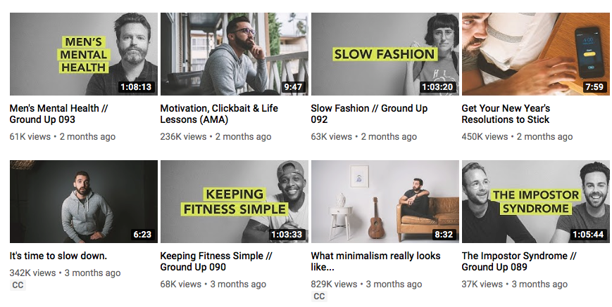
Having a simple and eye-catching thumbnail for your videos will increase your customer engagement by 154% according to BuzzFeed. Since our eyes are naturally drawn to images, you'll most likely fail to attract more clicks on your great videos if you use the usual and boring thumbnails. YouTube makes it extremely easy to create thumbnails by giving you the option to choose a custom thumbnail when you upload your videos. You want to make sure that you have a distinct thumbnail for each video that you upload and make sure that they set the users expectations for what they will get when they click on your video. You also need to make sure that you create a compelling title to gain the attention of your target audience.

Add Annotations to Drive User Actions
If you want your viewers to do something, then you have to state what you want them to do explicitly. If you aren’t upfront with your communications, you run the risk of simply getting more views on your videos without seeing any profitable customer action or increasing your YouTube engagement. An excellent way for you to bolster your subscriptions and increase participation is by using annotations, which are little boxes that appear during the video that remind viewers to take action. The four primary goals of adding annotations to your videos are to gain subscribers, grow your viewership and watch time, interact with your target audience, and drive traffic to your external website.

YouTube also like to see more interaction in the form of comments, shares, and likes, so adding a simple annotation or encouraging viewers to share your videos on their social network can be extremely helpful. You’ll need to experiment with the different types of annotations and their timing to ensure you are getting the best results for your efforts.

Keep Your Videos Short
The video watch time is a key ranking factor for videos. The percentage of your video watched carries more weight than the number of minutes watched, but you still want to try and improve the score of both. Thanks to our decreasing attention spans, it can be a considerable challenge to get more people to stick around and watch your videos. Reports have shown that on average, a user will only spend 20 seconds on a website. Which makes it incredibly important to grab the attention of your viewers in the first 10 seconds. You also want to keep your videos to no longer than three minutes.

Basic SEO Principles and Marketing Strategies Apply to YouTube
The fundamental marketing principles remain the same no matter what platform you’re using. The only thing that might differ is how you implement the tactics. One thing that you want to keep in mind is that to increase engagement; you have to promote your videos actively. You can do this through email marketing, embedding the video in a blog post, promoting it on social media and other avenues discussed for growing your audience.

You can also increase engagement with your videos by including keywords in your descriptions and video tags. You can utilize Google Keyword Planner to help you determine the best keywords to place in your videos. Using relevant keywords will not only help you appear in YouTube searches, but it can help your videos to rank high on Google and other search engines.

Engaging with your audience will help you gain more subscribers and build your YouTube channel. Leveraging these simple tactics can help you grow a successful YouTube channel for your business.

Chapter 7 – How to Monetize Your YouTube Channel
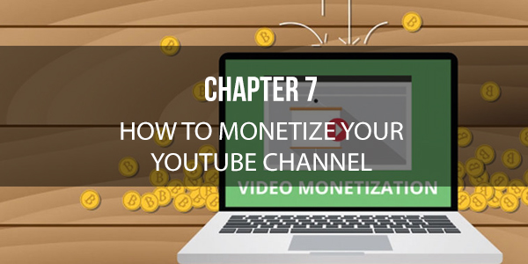
One of the main reasons why people start to create videos for YouTube is to make money. If it weren't for the fact that people can potentially make a living off uploading videos, most wouldn't even bother with creating videos. While anything is possible with YouTube, you can't realistically expect to make thousands of dollars in the beginning. However, you can look forward to earning a decent side income in due time as long as all the factors come together. It is essential that you realize that you must have an audience before you can even consider making a profit with the following tactics for monetizing your YouTube channel.

YouTube Partner Program
Signing up for the YouTube Partner Program is one way to display ads on your videos, but to be eligible for the program you’ll need to adhere to some strict guidelines. First and foremost, you have to own the copyright to the content in your video. You also can’t include any sexually explicit material, profanity, or violence in your videos. You also have to have a Google Ads (https://ads.google.com) account so you can get paid the cost per impression for your video views. The advantage of using this form of revenue is convenience. However, it is also much easier to be permanently banned from monetizing your videos if you break any of the rules.

Affiliate Products
If you are an affiliate marketer, this is the perfect opportunity to create a video reviewing a product and implementing your affiliate link in the description. Alternatively, you can choose to create a video promoting the product instead. You can also apply your affiliate links in your channel's about section as well. The one thing that you want to make sure of is that the affiliate product that you are promoting is within the scope of your niche.

Work with Outside YouTube Partners
This is the preferred way to monetize your videos with advertising. You aren't placed at any immediate risk of becoming banned in regards to trivial matters. Couple this with the fact that external YouTube partnerships are much more flexible. This method will take a bit of time before you can implement it on your YouTube channel because you have to build up an audience before you can become eligible to sign up with these partners. The different networks will have different criteria for partnering with them, so you'll have to do your research.

Sell Your Own Merchandise
If you can create products to sell that you target audience might be interested in, this is an excellent method for indirectly monetizing your YouTube channel. By leveraging the power of your brand, you can effectively offer merchandise that pertains to your channel. This could be anything from custom t-shirts, coffee mugs with your logo, to information products that you might have for sale. Whatever it is that you have to offer, you can choose to use strategically placed, clickable annotations in your videos to promote your products.

Drive Traffic to Your Website
If you have a website or a blog, you can drive traffic through your YouTube channel to help boost your sales. If your site is relevant to your niche, you can create promotional videos for it. You can also add a call to action at the end of your videos telling viewers to visit your website. If you have a site that needs a boost to its traffic, you can leverage your YouTube videos strategically.

If your goal is to monetize your YouTube channel, these simple strategies can help you set your channel up for success. It's relatively easy to make money from your YouTube videos; you just have to know the right methods and take the time to set them up properly.

Chapter 8 – Mistakes to Avoid on Your YouTube Channel
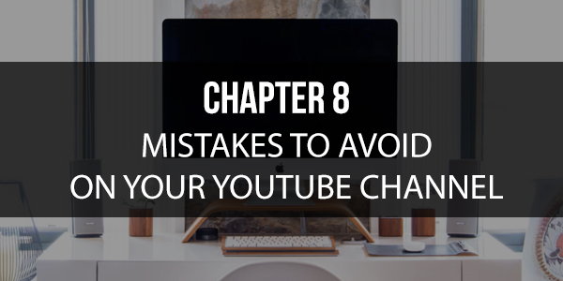
Now that you’ve established a YouTube channel for your business, you will likely find a ton of advice on how to make a quick buck. Since you want to become successful quickly, you may be tempted to take shortcuts. There are some mistakes that a majority of new YouTubers commit just because they don't know any better.

If you want to avoid crashing and burning, then you need to make sure you don't make these mistakes. If you can avoid the following pitfalls, you'll significantly increase your chances of successfully growing your YouTube channel for your business.

Purchasing Fake Reviews
This is a mistake that is made often out of sheer desperation. Buying fake reviews to increase your stats on YouTube will only boost your popularity for a short time. New viewers are more likely to become suspicious if they notice a new channel that suddenly has thousands of views but with hardly any engagement. This raises a ton of red flags, and those legitimate prospects will just walk away.

Doing a Video Dump
While you may have created some excellent videos back in the day, the last thing you should do is use your YouTube channel as a dumping ground. You need to treat your channel like a unique website that is meant to promote your business. You may link your YouTube channel to your website, but that doesn't mean every video on your site should also appear on YouTube.

Ignoring Your Social Media Presence
You can't expect to establish a successful business if you ignore your social media presence. Marketing your YouTube channel through your social media channels is the best way to reach as many people as possible, and quickly. Many new YouTube channels make the mistake of thinking that it's enough just to promote their videos on YouTube. However, if you want your videos to be seen, then you have to maintain an active presence on your other social media networks.

Inconsistent Video Uploads
The key to building and growing your YouTube channel is consistency. If you want viewers to come back to your channel and subscribe, then you have to make sure you are uploading content on a regular basis. If you're going to become successful on YouTube, then you have to continue to be active on your channel by uploading content consistency.

Not Engaging With Your Audience
Your YouTube channel is a way to make you money. However, it will be difficult to be successful if you forget to engage with your audience regularly. Get involved by asking your audience questions, responding to their queries and interacting with them. The more you participate, the more your audience will be eager to become loyal subscribers.

Failing to Have a Plan
If you don't ask yourself what you want to achieve with your YouTube channel, then you are more likely to get sidetracked and distracted by other things. Starting the journey is just one step. Your YouTube channel will only take you as far as your goals are willing to go, so make the time to create goals, milestones, and deadlines. This will significantly help you steer your upload schedule, marketing strategies, and social media engagement level.

Trolling Other Channels and Begging for Views
How many times have you looked at the comments section of a YouTube video and seen someone asking for others to click their link and check out their awesome video? This reeks of desperation. You don’t want to try and build your channel like this. It tends to aggravate the owner of the channel because you are using their platform to direct his audience to some unrelated video. It also annoys the audience. Instead, watch someone’s video, leave a valuable comment, and if your feedback is meaningful, people will want to know who you are and click on your username.

Not Linking Your Channel to Your Social Media Accounts
Never forget to link your Twitter, Instagram, and Facebook accounts to all of your videos, as well as your About page. You can also include annotations at the end of every video where you tell people about your other social media pages. This will prompt viewers to find you on social media and may even share your videos with others. It is important to remember that your YouTube channel is part of a long-term plan, so informing people about your other social media accounts will help to promote your business in the long run.

Conclusion

Creating your own YouTube channel for your business is an excellent way to expand your reach and earn some extra income. The thing that you need to remember is that you have to adopt the right strategies when you are first building your channel.

Once you get going, you need to stay consistent and follow your plan so that your audience sticks with you for the long run. Make sure that you are leveraging the power of social media to promote your YouTube channel and as a way to regularly engage with your target audience. There are many pitfalls that new YouTubers fall into, but if you follow the advice in this book, you’ll be better equipped to avoid them. Never forget that you must always put your audience before income.

Having the right strategy for your YouTube channel will always lead you to find a balance between useful video content and profit. Now that you have been provided with the key strategies to make your YouTube channel successful, you now have all the tools you need to reach millions of viewers and increase the overall profit for your business. As long as you can maintain a loyal and engaged group of subscribers, and continue to upload relevant videos they love, you’re guaranteed to have a successful YouTube channel.

