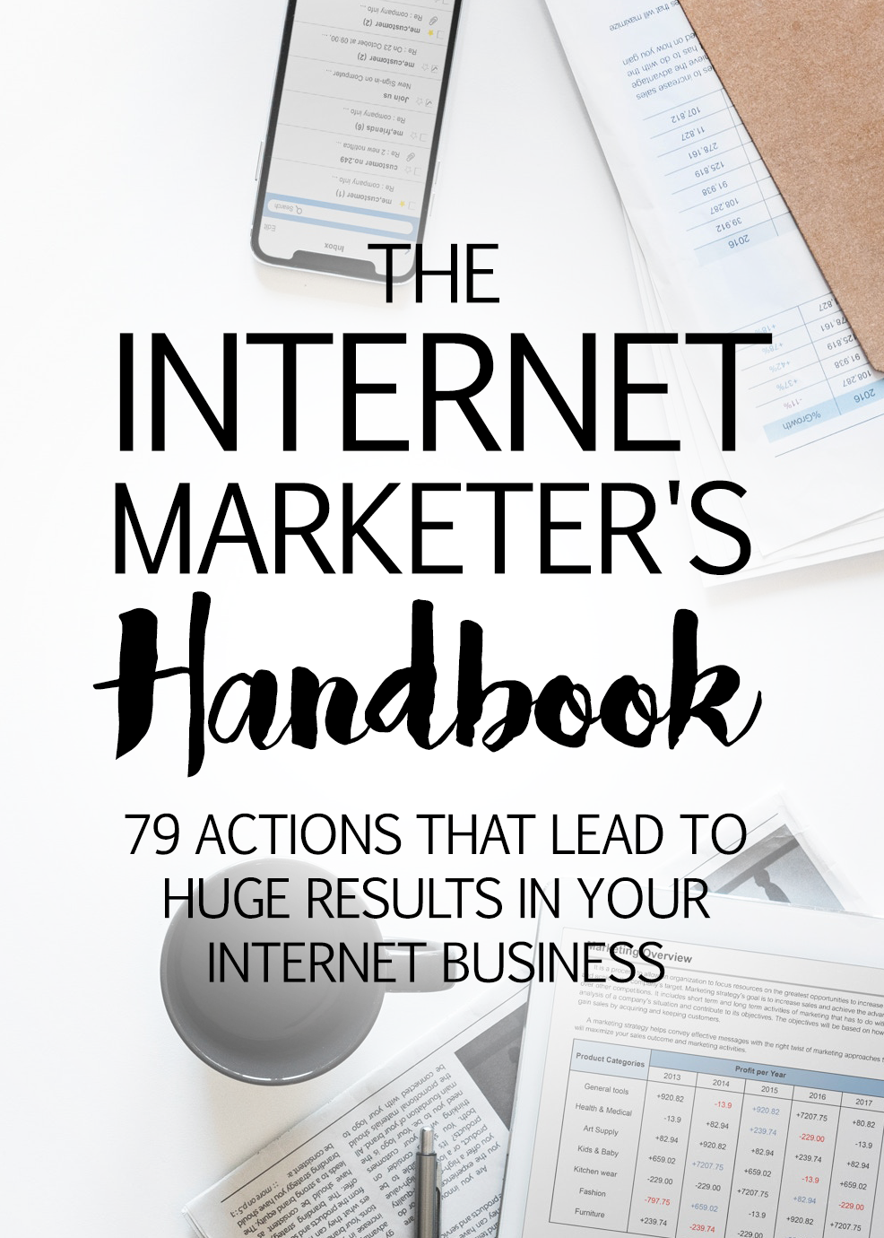
Disclaimer
This e-book has been written for information purposes only. Every effort has been made to make this ebook as complete and accurate as possible. However, there may be mistakes in typography or content. Also, this e-book provides information only up to the publishing date. Therefore, this ebook should be used as a guide - not as the ultimate source.

The purpose of this ebook is to educate. The author and the publisher do not warrant that the information contained in this e-book is fully complete and shall not be responsible for any errors or omissions. The author and publisher shall have neither liability nor responsibility to any person or entity with respect to any loss or damage caused or alleged to be caused directly or indirectly by this ebook.

About the Author

{first_name} {last_name} is an entrepreneur living in {country} who loves sharing knowledge and helping others on the topic of {topic}.
{first_name} is a passionate person who will go the extra mile and over-deliver.
{first_name}'s words of wisdom:
"I believe that knowledge is power. Everyone should improve themselves and/or business, no matter what stage in life they're in. Whether it's to develop a better mindset or to increase profits. Moving forward is key."
If you would like to learn more from {first_name} {last_name}, please visit:
{your URL}

Table of Contents
Introduction 9
Chapter One – Product Market Fit Hacks 10
#1 - Validate Your Idea in Less Than an Hour 10
#2 – Add a Video Background to any UnBounce Landing Page 11
#3 - Create a Metrics Dashboard That Keeps You On Top of Your KPIs 12
#4 - Benchmark Your Cost Per Acquisition Target 13
#5 - Ensure Your Product Solves Real Customer Problems 14
#6 - Determine Your Optimal Product Pricing with Psychology 14
#7 – Conduct Simple A/B Tests on Your Landing Page 14
#8 - Find the Perfect Name for Your Product or Service 16
#9 - Use Google Ads to Test Demand for Your Product 16
#10 – How to Watch Customers Interact with Your Website 17
#11 - How to Use Survey Monkey to Collect Customer Feedback 17
#12 - How to Use Qualaroo to Collect Instant Feedback 18
#13 - How to Collect Data About Customer Activity on Your Site so you Can Make a Better Product 18
#14 - How to Hack the Best Keyword Research for SEM and SEO 19
#15 - How to Create a Form-Based Website 20
#16 - How to Automate Lead Scoring to Funnel Leads to Specific Landing Pages 21
#17 - How to Get The Advice You Need Without a Huge Network 21
#18 - How to Start a Blog in Under 5-Minutes 22
#19 - How to Start Building Your Email List 22
#20 - How to Hack a Marketing Plan for Your Business Launch 22
Chapter Two – Hacks for Transitioning to Growth 23
#21 – How to Create a Viral Pre-Launch Signup Form 23
#22 - How to Make Sharing Easier with an UpVote Widget 24
#23 - How to Create a Viral “Invite a Friend” Thank You Page 25
#24 – How to Create a Press List Using the Power of the Crowd 25
#25 – How to Target Influencers with Followerwonk, Klout, or Brand24 26
#26 – How to use "Help a Reporter Out" to get your startup some PR 26
#27 – How to Syndicate Your Blog for Additional Inbound Traffic 27
#28 – How to Analyze Your Blog for Clues on How to Optimize It 29
#29 – How to use Customer Testimonials To Support Your Product Features 30
#30 – How to Identify the Most Popular Topics using Buzzsumo 30
#31 – How to Create a Simple Customer Newsletter with Linkydink 31
#32 – Send Your Different Traffic Sources to Different Pages 31
#33 – Growth Hack Your Customer’s Attention Spans with a Progress Meter 32
#34 – Create Your Own Daily Deal to Send to Your Customers 32
#35 – How to Create a Huge Content Shadow 33
#36 – How to Hack a Subscription e-Commerce Business 33
#37 – How to Hack an Easy and Effective Online Store 34
#38 – How to Hack a Cheap Product Demo Video 35
#39 – How to Offer Live Chat Customer Support on Your Website 35
#40 – How to get started with analytics with the help of Quill Engage 36
#41 – How to Turbocharge your Content Production with Text Broker 36
#42 – How to Stay in Front of your Customers by Retargeting 37
#43 – How to Hack Google’s Quality Score to Lower Your Cost Per Click 37
#44 – How to Infiltrate Your Customer’s Inbox with Gmail Sponsored Promotions. 38
#45 – How to Use YouTube Video Ads to Save Money 38
#46 – How to Get Better Traffic Quality with Google Ads Bid Multipliers 39
#47 – How to Drive Lead Volume Using Google’s Mobile Ads Call Button 40
#48 – How to Use Reddit and HackerNews to Acquire New Customers 40
#49 – How to Acquire Customers with LinkedIn’s Visitor Tracking Code 41
#50 – How to Start Your Own Social Network with Spot.im 41
#51 – How to Attract the Right Visitors by Creating Lookalike Audiences on Facebook 42
#52 – How to Use Twitter Cards to Increase Leads, Subscribers, and Sales 43
#53 – How to Customize Share Buttons with AddThis to Encourage Sharing 44
#54 – How to Encourage and Incentivize Sharing with Click to Tweet Style Links. 44
#55 – How to Create, Launch, and Test Facebook Ads Using AdEspresso 45
#56 – How to Hack a Social Media Marketing Plan 45
#57 – How to Create Engaging Infographics for SEO Backlinks and Shareable Content 46
#58 – How to Create an Easy and Effective Viral Referral Email 46
#59 – How to Create Emails that Your Customers will Care About 47
#60 – How to Create Your Own Photos with ShutterStock Custom 48
#61 – How to Spy on your Competition 48
#62 – How to Use One Simple Questions to Make Sure Your Customers Are Happy 49
Chapter Three – Scaling for Growth Hacks 50
#63 – How to Get Serious with Your SEO Using Moz 50
#64 – How to Match Your Page Content with Your Offer 51
#65 – How to Grow Your Twitter Follower Count 51
#66 – How to Create Personal Content for Your Website 52
#67 – How to Know Which Metrics Are Critical to Measure 53
#68 – How to Use Zapier to Make Your Life Easier 54
#69 – How to Become a Thought Leader with Email Courses 54
#70 – How to Send Email to Users Who Haven’t Referred a Customer Yet 55
#71 – How to Implement Automatic Trigger Based Emails 55
#72 – How to Collaborate With Users on Product Development 56
#73 – How to Hack Your Site pages for Increasing Organic Traffic 56
#74 – How to Track and Follow Up on Social Media Mentions 57
#75 – How to Make HubSpot Your Marketing Ground Zero 57
#76 – How to Have a Personal Assistant Without Breaking Your Budget 58
#77 – How to Outsource Your Market Research 58
#78 – How to Create Your Own Growth Hacking Hub with Pocket 59
#79 – How to Keep in Touch with Your Network Through LinkedIn Connections 59
Conclusion 60

Introduction

When you decide to start a business, it can be incredibly intimidating to learn how to market your company effectively. With so many changing trends and advice on the market, it can get somewhat confusing to know which steps to take first. Within this book, you'll find 79 actionable things that you can do that will lead to tremendous results in your Internet business, from ensuring your product fits the market, to transitioning for growth, to how to scale your business for substantial growth.

Chapter One – Product Market Fit Hacks
Before you can get started making money with your Internet Business, you need to make sure that your business idea is a valid one and that you're selling something your customer wants. This first section will show you some proven methods for quickly and cheaply ensuring that what you're planning on selling is something that your customers actually want. Once you have proof that your product will fit the market, then you can move onto the steps you need to take to acquire customers and grow your business.

#1 - Validate Your Idea in Less Than an Hour
It can be incredibly easy to imagine that your latest idea will become an overnight success, but without validation, you could end up wasting your time and money. You can use Unbounce.com (https://unbounce.com) or LeadPages (https://www.leadpages.net) to quickly setup a landing page so you can fuss less about the technical aspects of setting up a landing page and focus more on validating your idea.
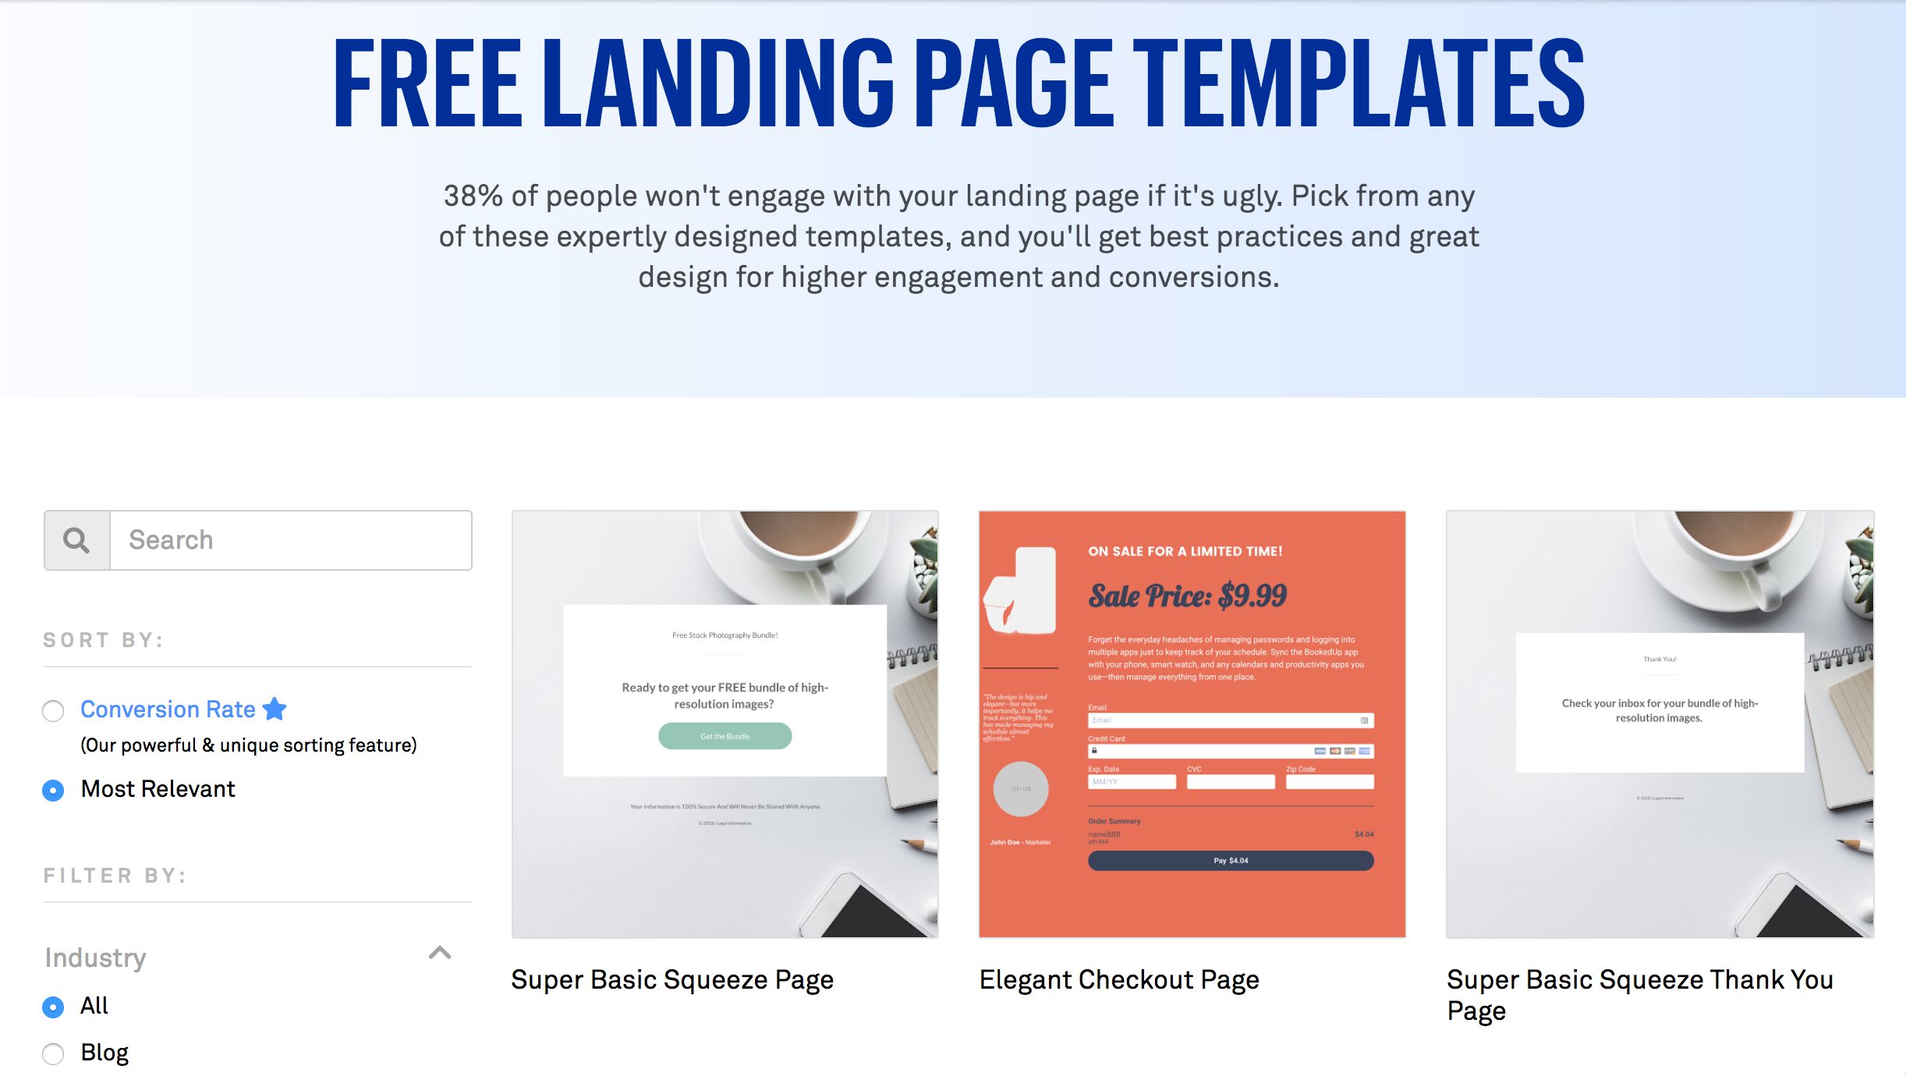
The process is simple, all you need to do is select a template, add your images and content, and then forward your business site to your newly created unique landing page and start sending traffic to the new landing page. Make sure that you measure the click-through rates and conversion rates from each traffic source.

#2 – Add a Video Background to any Unbounce Landing Page
These days, landing pages that have video backgrounds are extremely popular. You can learn how to add a video background to your landing page to compete with the big boys. Adding a video background to your landing page will not only make your site look more professional, but you will still be able to maintain a lean start-up launch. You can find detailed instructions on how to do this here: https://documentation.unbounce.com/hc/en-us/articles/203660914-Adding-Video. You want to make sure that you also have a static background image that the page can default to for unsupported browsers and mobile phone users.

#3 - Create a Metrics Dashboard That Keeps You On Top of Your KPIs
You can’t manage what you don’t measure, but measuring is only half the battle. You also need relevance. These days, data is incredibly fashionable, and like most things stylish, data quickly becoming a real head turner for businesses and marketers. This is because there are mounds of data available online for free.

To make the most of this open data, prioritize the three or four KPIs that are most important to your company. Rather than getting intimidated by attempting to track dozens of metrics, all you need to do is focus on the most important ones for your business and follow them obsessively. You can create a customized KPI dashboard using Cyfe (https://www.cyfe.com/web-analytics-dashboard) and keep your entire team on the same page.


#4 - Benchmark Your Cost Per Acquisition Target
If you've ever spent time raising venture capital financing or studying SaaS marketing, then you've probably already heard of Cost Per Acquisition, CPA, which is the amount of money that you spend to acquire a new customer. You can quickly learn how to calculate your target CPA and never again pay $50 to obtain a customer who's only worth $20. For businesses that are looking to grow, the CPA is the lifeblood of your company because you should always be aiming to acquire new customers in the most efficient way possible. When you track your CPA, you can ensure that your company is focusing on the marketing channels that will generate profitable customers.

#5 - Ensure Your Product Solves Real Customer Problems
You don’t want to spend your time and money developing a product that no one ones, which is why you need to take the time to make sure that your product solves a real customer problem. To help ensure that your product or service is addressing a genuine customer need, you can use Alex Osterwalder’s Value Proposition Canvas tool to map out your company’s business model and test it against other alternative models.

#6 - Determine Your Optimal Product Pricing with Psychology
Our minds can easily be tricked into choosing options that might not necessarily be in our best interests. Sometimes these choices may even be damaging to maximizing utility for us as consumers. For example, the concept of value is a relative term and, logically, it has no absolute worth. It's a proven fact that a "fair" price can differ for the same service or product depending on the context and circumstances. As a business owner, you need to use this psychological loophole to maximize the perceived value of your products. You can use what is called the decoy effect. When done right it can increase sales.

#7 – Conduct Simple A/B Tests on Your Landing Page
If you want enormous results for your internet business, then you have to conduct A/B testing because it has the potential to uncover valuable customer feedback. Performing just one A/B test a week will result in around 50 tests in a year, which could provide you with 12-15 significant improvements for your business. As a non-technical marketer, you’re probably thrilled that you were able to get one website launched, let alone testing multiple versions.



Defining an experiment by identifying a website variable and creating multiple version of your website to test that variable will give you insight into which one will perform better. Splitting your traffic between the two versions, allows you to gauge the response and switch to the version that performs better.

#8 - Find the Perfect Name for Your Product or Service
If you're like most entrepreneurs, you've probably shopped around for a branding agency and been stuck with several thousand dollars' worth of sticker shock. Rather than spending your hard earned money on a service that will provide you with too many ideas, why not do it yourself. It can be difficult to come up with a great name for your product or service, but with crowdsourcing, you can harness the power of the crowd to get a cost efficient result. A great resource for this is NamingFoce.com (https://namingforce.com). For $250 they’ll provide you with upwards of 1,000 name ideas that you can choose.

#9 - Use Google Ads to Test Demand for Your Product
In the hugely successful book, “The Four Hour Workweek," Tim Ferris describes how you can leverage a small spend on Google Ads to find out if anyone wants your product before you spend time and money launching it. Using Google Ads will also generate some great data on keyword performance, advertising concepts, and geography that you'll find invaluable.

This is what is known as "micro-testing" which is the process of executing small, inexpensive tests, prior to your launch, to see if customers respond to your offer. In the days before the Internet, entrepreneurs would use small display ads or classified ads in a targeted magazine. Today, Google lets you target customers at the point of search, which makes it a much easier and better-targeted strategy.

#10 – How to Watch Customers Interact with Your Website
Seeing how users are interacting with your website can be extremely beneficial for your business. The company, UserTesting.com (https://usertesting.com), provides businesses with the ability to gain videos of targeted users interacting with your website. The company has you set up tasks for the users, ask them questions, and get their feedback. Then within minutes, you can watch the videos of them doing this and provide you with immediate feedback. The users get paid to interact with your website. While testing, audiences aren't engaged website users, their feedback can be beneficial.

#11 - How to Use Survey Monkey to Collect Customer Feedback
If you don’t know, Survey Monkey (https://surveymonkey.com) allows you to create, circulate, and analyze customer surveys, to find out what your customers really need. This can be extremely helpful for creating buyer personas. This is what's known as "customer development" and is the most essential part of starting a business. The easiest way to solicit customer feedback is through a well-planned survey. Start collecting feedback from your customers with a free account at Survey Monkey, or get even more responses by upgrading your account.

#12 - How to Use Qualaroo to Collect Instant Feedback
Your website is your most important digital marketing tool your business has, and the visitors to that site provide you with the most significant opportunity to monetize this particular marketing channel. Traditionally, you haven't been able to query your visitors while they're browsing your site. Enter Qualaroo, (https://qualaroo.com), a company that allows you to ask your visitors questions as they navigate through your site. This will enable you to understand their needs, as well as their challenges better, to ensure that your site is meeting them. Qualaroo lets you deploy mini-surveys or questions based on the visitor's navigation and based on their previous answers.

#13 - How to Collect Data About Customer Activity on Your Site so you Can Make a Better Product
This hack will show you how you can track how people use your website or application, and utilize the data you gather to unlock deep insights that will help you grow your business.

You’ll need to sign up for a free account at Trialfire.com (https://trialfire.com) and add their code snippet to your site. This will allow Trialfire to automatically begin collecting every page-view, click, form submission, and other action that happens on your site. It will then build reports with a single click on your site. With this, you can quickly create segments of your visitors in a few clicks that you can then use in your targeted marketing campaigns.

#14 - How to Hack the Best Keyword Research for SEM and SEO
The terms SEO, Pay Per Click, and Content Marketing aren’t going anywhere anytime soon. At the root of all of these marketing strategies is keyword research. Knowing which keywords you need to target and promote, can be the difference between the life and death of your business.

A majority of your online marketing is reliant upon keywords, so you need to give them the attention they deserve. You can start with Google's keyword planner tool, but there are many services that can take the baseline list. Google provides you and turns them into a massive list of keywords.

When you start spending money with Google Ads, you'll quickly learn which keywords are the most profitable so you can begin to focus your resources on those ones. Until then, you need to cast a wide net because you don't know which ones will be profitable. You can find the steps for completing this process at SEOnick.net (https://seonick.net/keyword-research).



#15 - How to Create a Form-Based Website
You’d be amazed at the data that you can collect when you provide a highly interactive landing page that contains a form or survey interface. With Typeform (https://typeform.com), you can create a super slick looking from and embed it onto your site that will create a lead generating landing page that not only looks great, but that is fun for the user. They provide an enormous suite of integrations, and you can connect your form to a ton of different services, like MailChimp. Once you get comfortable with Typeform, you can start to use their conditional logic to ask respondents different questions that are based on how they answered the previous question.

#16 - How to Automate Lead Scoring to Funnel Leads to Specific Landing Pages
Imagine a web form that can collect lead data, score each lead, and direct them to a specific landing page, based on their score. This could ensure that each qualified lead would be taken to the page the best fits their needs to increase the chance that you’ll convert them. With the help of Formstack (https://formstack.com), you can do just that. Formstack allows you to set up a form that will score the key questions, with a hidden field for the total score. Based on the total score they receive, the user will get a different confirmation message and call to action that you set up. You can use custom messages for short and simple calls to action and use external landing pages for more detailed offerings.

#17 - How to Get The Advice You Need Without a Huge Network
As a business owner having a fantastic network of contact is worth its weight in gold. However, it can take years to build a network of trusted individuals and can take years of your time investing in relationships without taking and adding value to their lives. There are many sites and services that you can use to get the right advice from people who have the right experiences, at just the right time. With a bit of research and some effort on your part, you can get solid advice on the challenges that you're facing and use the information you get to make the best decisions for your business. You can use sites like Inbound.org (https://inbound.org), Guides.co (https://guides.co) or Clarity.fm (https://clarity.fm) to get the advice you need when you don’t have a network.

#18 - How to Start a Blog in Under 5-Minutes
Launching a blog is easy to do, and it engages your brand with your customers while providing free organic traffic for years. The updated content on your site also signals to Google that you're still in business. When you hear about content marketing, a lot of times it simply involves creating amazing content through your company blog and then amplifying the reach of the material through email, social media, and other paid channels.

#19 - How to Start Building Your Email List
Email marketing is the highest converting channel that you have at your disposal. One of your top priorities as a business owner is to collect as many qualified email addresses that you can. When you have a healthy email list, you can market to a pre-engaged audience and create massive, custom audiences based on the characteristics of your list. Email marketing continues to remain one of the highest converting channels in a business’ marketing tool kit.

#20 - How to Hack a Marketing Plan for Your Business Launch
When it comes time to market your product launch, you’ll want to save time determining the best marketing channels to utilize. In their book “Traction,” Justin Mares and Gabriel Weinberg introduce a methodology called Bullseye, which helps you brainstorm, analyze, and rank various marketing concepts over 19 different proven marketing channels. Going through the exercise will help you to select three channels that you can test inexpensively and in parallel to hopefully find a promising channel that you can optimize and scale.

Chapter Two – Hacks for Transitioning to Growth
After you've proven that your product will fit the market, the next thing that you'll need to do is to start searching for growth opportunities. This is where you will be more scientist than a marketer. At this point, you want to begin to think about building marketing machines in your business that provide predictable, scalable, and dependable revenue. You'll want to approach this phase of your business with an open mind and a healthy curiosity to experiment with different marketing opportunities, different channels, and different funnels.

#21 – How to Create a Viral Pre-Launch Signup Form
It may sound impossible, but you can acquire two, three, four or more users in one fell swoop when you create a viral pre-launch signup form. While you may already have a landing page for your product that allows people to leave their email and join a waiting list, but too often that's where things grind to a halt. However, you can create a viral sign-up form to keep the traction moving forward. With a viral pre-launch form, users who share your app with a certain number of friends get put on your launch list. Those who share more get to move up high on the waitlist.

After users sign up for your waitlist, they receive a custom URL that they can share with their friends. You can track the URL and set up an email auto-responder series to send out emails to notify the waitlister each time someone has signed up as a result of their invites. Once they've invited the required number of people, they get a final email letting them know they've made your launch party. This can help to create tremendous buzz and excitement around your product launch.

#22 - How to Make Sharing Easier with an UpVote Widget
Running a blog is difficult. At times, it can end up consuming more of your mental space than anything else in your business. However, by making it easier for others to share your content, you can at least get rewarded for all your hard work. While you can take the easy road and install sharing buttons all over the place, and implement a ton of other complex tricks to give your visitors more reason to stick around, there's something you can do that's much simpler, invest in upvoting.

Upvoting has made sites like Reddit and Buzzfeed popular by letting readers have a direct say in what content becomes popular. With the Love It Pro WordPress plugin, you can dramatically increase your blog's stickiness. You can use the plugin to put the upvoting power if your reader’s hands. Readers get to vote for the content they like best and feel more invested in your blog’s success.

#23 - How to Create a Viral “Invite a Friend” Thank You Page
After you’ve opted in a new email subscriber, the last thing you should be doing is sending them a boring, standard edition, “Thank you for subscribing” message. When a visitor is impressed enough by your content to subscribe to your newsletter, why not seize the opportunity, when they are most compliant and send them an “Invite a Friend Thank You” message instead. You need to capitalize on your new subscriber’s euphoric state and hit them with a confirmation page that asks them to do something, like telling their friends about your product, or getting them to sign-up for your webinar. The goal here is to strike while the iron is hot.

#24 – How to Create a Press List Using the Power of the Crowd
You know that your business needs publicity, but the problem isn't publicity isn't your forte. What if someone told you that you could easily target your publicity efforts so that you can get the most bang for your buck and substantially increase your press coverage. Luckily you can utilize the power of Amazon Mechanical Turk (https://mturk.com), to help you gather the names and contact information of the reporters who have experience in your industry.

#25 – How to Target Influencers with Followerwonk, Klout, or Brand24
We are all drowning in information, and the only way we can stay above the water is to filter out the noise. One way you can help your users do this is by working with influencers who can become the gatekeepers of relevant content and can become your best marketing allies. Reaching out to influencers, if done right, is one of the most effective ways to quickly grow your company. The key to finding these influencers is by using a multitude of tools that are available for this exact purpose. Some of the most popular apps that you can use to analyze and grow your social graph are Follwerwonk (https://followerwonk.com), Klout (https://klout.com/impact-ranking), or BuzzSumo (https://buzzsumo.com).

#26 – How to use "Help a Reporter Out" to get your startup some PR
Generating PR for your business typically involves pitching stories to various journalists in the hopes that your story will catch their attention. However, there is a much easier way to get some PR. You can use “Help a Reporter Out (https://helpareporter.com) and provide them exactly what they’re looking for, by monitoring your daily email from the site.
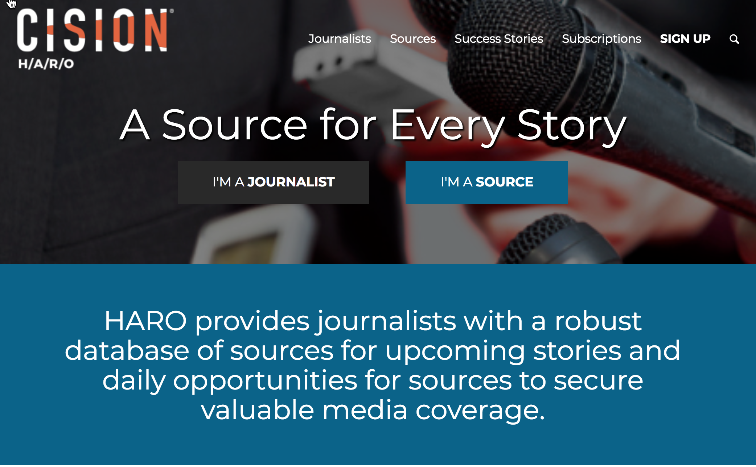
The email you receive features a list of topics that reporters are looking for experts on. When you find one that fits, pitch your story to them. Journalists use HARO to post the article topics they are looking to find experts in that can provide them with input and interviews, in exchange for getting a valuable mention in their article.

#27 – How to Syndicate Your Blog for Additional Inbound Traffic
If you’ve written the perfect blog post, but haven’t gained any organic traffic from it yet, you can use BoostSuite (https://boostsuite.com), to work with other companies to trade content to gain new traffic. The site offers a co-marketing platform for businesses that allows you to swap blog posts with other related, but non-competitive sites. This can result in your blog post getting more exposure, which can lead to new organic traffic sources and increased exposure for your blog and your business. It also gives you additional content for your site that you would otherwise have to create yourself.

#28 – How to Analyze Your Blog for Clues on How to Optimize It

It’s time to take your blogging skills and make them scientific. However, apart from using Google Analytics to analyze your posts and run heat maps, is there anything else you can do? With Import.io (https://import.io) and Shared Count (https://sharedcount.com), you can gain a better understanding of your blogging to improve the virality of your posts. Import.io lets you scrape your blog by creating a crawler that will extract everything from your blog, including the meta-data. You can then use this information and import it to Shared Count to see how much love each post got on social media. Knowing this information will allow you to optimize your blog.

#29 – How to use Customer Testimonials To Support Your Product Features
Being able to successfully grow your business all comes down to your credibility. An easy way to gain credibility is by getting some good old-fashioned social proof that will make your business stand out. Placing customer testimonials on your website will help to increase its perceived credibility. However, many business owners place their customer testimonials at the end of the page. Instead, you should add a customer testimonial to each feature that you are selling. This way, your customer testimonials are less generic and more believable.

#30 – How to Identify the Most Popular Topics using Buzzsumo
Content marketing can be hard work, and there's a reason why they call it "feeding the beast." It can be incredibly easy to run out of content ideas and give up at marketing your business. However, there is an easier way to stay on top of the constant demand for high-quality content. Think about all of the blog posts and articles that you've read and thought, "I could expand on that and make it my own." Well, you can with the help of BuzzSumo. Use the site to find content that ranks highly in your industry, and analyze it. Then brainstorm your own thoughts on the subject and then package your thoughts into a brand-new post and reach out to those who promoted the original piece of content.

#31 – How to Create a Simple Customer Newsletter with Linkydink
When it comes to converting users into paying customers, email is still king. However, creating a full-blown email marketing strategy takes time and effort to execute properly. Unfortunately, when you are first starting out, there are other growth opportunities that you need to pursue. So, how can you solve the dilemma of regularly showing up in your user's inboxes without having to commit a ton of time to create a full-blown email strategy? You can do this with Linkydink (https://linkydink.io). For a small fee of $5, you can expand your group beyond five subscribers. The key is to keep your links relevant to users to help you keep the unsubscribes low.

#32 – Send Your Different Traffic Sources to Different Pages
Your landing pages can make or break your marketing campaign. Whether you’re managing Google Ads, reaching out to custom audiences on Facebook, or remarketing using the Google Display Network, any of these promotional methods require well-built landing pages. With Google Ads, you have to have great landing pages because it affects everything from your cost-per-click to whether your ads will even show in the first place. Even your unpaid channels like your social promotions and email campaigns, all require the services of your high-converting landing page.

To accomplish this, you need to have just one goal for each of your landing pages and only one link on the page, which should be your CTA. Your CTA needs to be the starting point for your page design and will change depending on the traffic source of your arriving visitor.

#33 – Growth Hack Your Customer’s Attention Spans with a Progress Meter
You need to understand that your users have the attention span of a goldfish, which means they are highly unlikely to go through each step of your onboarding process. Unfortunately, your activation numbers depend on getting users through the process. To get users interested for long enough to activate, you have to have something that will keep them glued to the screen. Fortunately, this doesn't involve a brain transplant. All you need is to include a progress bar for your most crucial activation processes to show users where they are in the process, and how little they have to go. WordPress has a handy little plugin for this.

#34 – Create Your Own Daily Deal to Send to Your Customers
Everyone likes a deal. Fortunately, you don’t have to be Groupon to offer your followers relevant and timely deals. You can create your own daily deals to send to your customer by searching the web for great discounts deals that would be relevant to your audience. Pick up three or four daily deals based on the interest of your customers and place them in your newsletter. Make sure that you're not sending these on a daily basis because you don't want your emails ending up being marked as spam.

#35 – How to Create a Huge Content Shadow
The benefits of content marketing include increase SEO presence, free inbound traffic, and becoming an authoritative and trusted source in your industry. To keep your content flowing, you can use UberFlip (https://uberflip.com) to create your own content hubs that will let you content market like the big guys. After you've signed up, you can customize your hub and start adding some feeds. Then you can add a small code snippet to your website so that Uberflip can add content to it.

#36 – How to Hack a Subscription e-Commerce Business
Subscription services are all the rage today, with tons of them popping up that serve the needs of beer enthusiasts, shavers, and video game geeks, to name a few. The reason they've become so popular over the years is twofold. First, thanks to companies like Dollar Shave Club entrepreneurs have seen how valuable the space can be. Secondly, the recurring revenue you gain from subscription services is quite impressive. They allow you to get one customer instead of six for the same price. The larger lifetime value for each customer lets you spend more on customer acquisition. With Cratejoy (https://cratejoy.com) you can quickly set up your own subscription box and start bringing in the recurring revenue.



#37 – How to Hack an Easy and Effective Online Store
When you need a quick and easy e-Commerce site to start selling the next Slap Chop, you can use Shopify (https://shopify.com) to help get you to market quickly. This is the quickest and most inexpensive way to launch a new e-commerce site. They can handle an onslaught of orders if your product is the next great thing, and if it turns out no one is interested in your new gadget, you won't have broken the bank. One of the best features of Shopify is the third-party app store. This allows you to quickly and easily add functionality to your online store.

#38 – How to Hack a Cheap Product Demo Video
Today’s marketing environment is all about video. This is especially true if you are catering to a younger demographic. Many of your site visitors prefer to see your product rather than read about your product. If you want to get your business noticed on social media, you have to include product videos. Fortunately, producing videos has never been easier or more inexpensive. You’ll need to start by determining what you want your demo to feature and in what order. Take some time to walk the customer through the key features of your product or service, making sure to focus on the key features and what sets you apart. Finally, end your video with a strong call to action.

#39 – How to Offer Live Chat Customer Support on Your Website
Being able to engage with and answer questions from your customers in the moment is why the live chat option on websites has become so popular. Live chat is a great way to deal with objections fast and can even help clear up misunderstandings if you are offering a complicated or detailed service. However, tying yourself to the computer to answer these questions is not all that appealing. You have two options. You can either use the page targeting options that the live chat providers offer to provide only live chat on key pages and at key times of day, or you can outsource the staffing with Olark (https://olark.com) or VMG BPO (https://vmgbpo.com). Both companies offer non-dedicated agents to man your live chat 24 hours a day.

#40 – How to get started with analytics with the help of Quill Engage
The success of your marketing, to some degree, depends on your ability to interpret your analytics to make good decisions. However, learning how to interpret analytical data is difficult, and it takes time. As you start to dive into your analytics, you'll quickly get better. In the meantime, you can use Quill Engage (https://quillengage.com) to get a simple snapshot of your analytics, and it will provide you with tips on how to improve.

#41 – How to Turbocharge your Content Production with Text Broker
Textbroker (https://textbroker.com), is a content creation service that can help you turn your content creation process into a production engine that will blast your content creation through the roof. While you want to focus on high-quality, consumer-centric evergreen style content most of the time, there’s something to be said for good old-fashioned content velocity, blogs on blogs, dripping with keywords and links. Unfortunately, we don’t always have the time or resources to spend on every blog post. That’s where Textbroker comes it, giving you’re the power behind their crowd and post writing gigs to their marketplace. This will give you good, fast, and cheap blog posts returned back to within hours or days, for only pennies per word.

#42 – How to Stay in Front of your Customers by Retargeting
Just because a visitor to your website isn’t ready to purchase from you today, it doesn’t mean they won’t be ready to purchase from you down the road. The problem is, how you can stay on top of their mind after they leave your site? The simplest way is by retargeting your advertising. Have you ever wondered why you visited a site one day and then saw their banner ad the next? The answer is retargeting ads. You can do this if you are using Google Ads to advertise your business or Facebook's AdRoll. Simply add a retargeting campaign to your Google Ads program that will place a "cookie" on visitors that come to your site, and it will effectively follow them around the web and show them your ad on participating sites.

#43 – How to Hack Google’s Quality Score to Lower Your Cost Per Click
When it comes to Google advertising, your quality score is everything. This is what determines where your ad appears and how much you'll end up paying for it, among other things. If you can improve your quality score, you can reduce your per click costs by up to 50%, which results in an 80% reduction in your cost per acquisition. An average quality score on Google is a five, but you should shoot for an eight or a nine. Many things can impact your quality score. You can use ad extensions and add site links to help increase your score. However, don't add too many extensions or adding extensions that aren't appropriate.

#44 – How to Infiltrate Your Customer’s Inbox with Gmail Sponsored Promotions.
Gmail Sponsored Promotions is a nifty way to get your business ads and name into your customers' inbox. If you’ve ever logged into your Gmail account and clicked on the “promotions” tab and seen the little ads at the top of your inbox, this is Gmail Sponsored Promotions. The ads that are displayed are served based on the content of your email. When a user clicks the ad, it expands to a big 650x650 graphic of your design. You can utilize this service by creating what’s called a “Display Network Only – All Features” ad.

#45 – How to Use YouTube Video Ads to Save Money
When you’re first getting your business going, you probably won’t be able to afford TV ads, but you can afford YouTube ads. Along with being much cheaper, they can target your audience better, and you only pay if the view interacts, and you can change them out daily. If you have a compelling video, you might want to consider turning it into a catchy ad. You can also use YouTube Video Promotion feature and pay to promote your video in search results.

#46 – How to Get Better Traffic Quality with Google Ads Bid Multipliers
You've been a good business marketer, and you've stayed on top of your data, meticulously searching for trends in the data that can lead you to better optimization. If you're lucky, then you have probably found some trends that are worth testing, but you aren't quite sure what to do with the knowledge. Well, you'll want to start using bid multipliers in Google Ads to test trends in data quickly to lead to more profitable clicks. Start by measuring the attributes that have an effect on your cost per acquisition, the use Google Ads bid multipliers to bid for attributes that lead to lower CPAs and fewer attributes that don't.


#47 – How to Drive Lead Volume Using Google’s Mobile Ads Call Button
When Google released their mobile ad, call button, they stated in the press release that 70 percent of mobile searches terminate with a phone call. This means that will all the innovation; searchers are using their phone and the Internet as replacements for the more traditional Yellow Pages. If you're looking to increase your phone leads, this is great news. The call to action in the ad is a button that initiates a phone call, and instead of paying for the click, you're paying for the phone call. However, you will still have to pay for the call regardless of whether or not the call is completed. If you utilize the Google call forwarding phone number powered by Google Voice, you can also set up conversion tracking for calls of a certain length.

#48 – How to Use Reddit and HackerNews to Acquire New Customers
While you might be an avid reader of Hacker News or Reddit, you probably aren't actively using the sites to promote your business, which means you are missing out on a huge opportunity. The good news is that it's not too late to change this and tap into these communities to acquire early adopters. This will pay large dividends, particularly if your product's user base overlaps with the psycho-demographics of these sites’ audiences. Also, it is important to remember that tech journalists frequent these sites often. This means that if you get it right, you could end up striking publicity gold. The key to being successful on both sites is to tailor your content.

#49 – How to Acquire Customers with LinkedIn’s Visitor Tracking Code
LinkedIn is often underutilized even though it has become one of the more powerful social networking sites. It provides businesses with a ton of interesting options for acquiring customers. One of the unique features of LinkedIn is that it gives you the ability to track other users who view your profile. This is something that you can't do with Twitter or Facebook. As a business owner, you definitely want to make use of this feature. One way you can do this is by implementing a bit of code on your website that allows you to see which LinkedIn users have visited it. For this to work, the user has to be logged into their account, and you have to have a paid LinkedIn Premium account. When these two conditions are met, you could have a powerful tool in your marketing arsenal.

#50 – How to Start Your Own Social Network with Spot.im
While Facebook and other social networking sites have their place in helping your business grow, with their powerful marketing tools and ability to talk to customers directly, ultimately they are marketing channels that you own, and everything that you do on these channels helps the social networks, and only the social networks grow. They are really nothing more than rented space. You might argue that it's the nature of social media. But what if there was a way that you could build your own social network? With Spot.im (https://spot.im) you can. The best part is you don’t have to spend billions of dollars or write millions of lines of code. Now that you have your own social network, you can smile because your user retention rates have skyrocketed.

#51 – How to Attract the Right Visitors by Creating Lookalike Audiences on Facebook

One of the most powerful advertising tools that you can utilize on Facebook is its lookalike audiences. The feature allows advertisers to "tell" them what their perfect customers look like, and then produces a massive lookalike audience based on the user behavior of the ideal customer. You can choose from one of three ways to define your ideal customer, either through your Facebook page fans, an email list of all your best customers, or with your conversion pixel that you put on your site. You can also follow the same process to create a negative lookalike list that's based on examples of your worst customers. Then you can target your positive lookalike audience while excluding your negative lookalike at the same time.

#52 – How to Use Twitter Cards to Increase Leads, Subscribers, and Sales
Twitter cards make it really easy for a prospective lead to engage with you without needing to click on anything or friction-filled conversions. The cards are graphical Twitter ad units, in which the call to action is to submit your email address in exchange for the content offered. By clicking on just one button, the lead submits their email address to you. The process is fairly simple and just requires you to create an advertising account with Twitter (https://ads.twitter.com). You can automate your Twitter card leads to flow into MailChimp (https://mailchimp.com) or Drip (https://drip.com), so you don't have to export the leads manually. Once you have the contact emails exported to one of these services, you can set up a campaign for the list and start marketing to them immediately.

#53 – How to Customize Share Buttons with AddThis to Encourage Sharing
Can you remember the last time that you were on a blog that had a variety of social sharing options, except the one that you prefer? Or maybe the blog had sharing buttons for all the social sites, but they all had zero shares, which of course, ends up taking away from the credibility of the article and makes most users less likely to share it. Social proof, or the lack of it, tends to have a powerful effect on our choices. Even if they're as small as sharing an article online. When it comes to social sharing buttons, having too few or too many is good. The solution for this is AddThis (https://addthis.com). Adding this plugin to your website will look at the other cookies on a website and then display the visitor’s preferred social sharing buttons, with very little effort on your part.

#54 – How to Encourage and Incentivize Sharing with Click to Tweet Style Links.
Share Link Generator (https://sharelinkgenerator.com), is a simple and free website that will allow you to create links that automatically populate social media shares and referral emails. You can use these links to make it super easy for your customers to share your message with your own crafted content. You can choose from Facebook, Twitter, LinkedIn, Pinterest, and email and use the simple form to populate the content of your share links.

#55 – How to Create, Launch, and Test Facebook Ads Using AdEspresso
AdEspresso (https://adespresso.com), is a Facebook ad platform that makes it easy to purchase Facebook advertising and optimize them into profitable ads. The platform performs dozens of micro-optimizations in the background so that you can focus on the big picture experimentation, letting AdEspresso optimize for ads for creative and copy. To get started sign up for an AdEspresso account and connect it to your Facebook account. Then place your ads, set your targeting, set your budget, and create your ads, just like you'd do on Facebook's native platform. AdEspresso will run a ton of small experiments in the background and provide you with actionable advice on how to optimize your ads to increase click-through rates.

#56 – How to Hack a Social Media Marketing Plan
As a business owner, you know you need to be active on social media, but you aren’t quite sure how or when to do it. Most social media marketers will admit to operating on an ad hoc basis, updating profiles only when time permits and sharing content without a specific strategy. While many marketers have proven that this approach can be successful, a better approach is to plan out your social media a month at a time. You can utilize services like Hootsuite (https://hootsuite.com), and Buffer (https://buffer.com) to help you plan and schedule your social media posts in advance.

#57 – How to Create Engaging Infographics for SEO Backlinks and Shareable Content
Everyone loves infographics, which means you should be creating them. They are consistently amongst the most shared content by bloggers and media sites. The more your infographics are shared, the more organic traffic you can attract. As a bonus, all of the links in your infographic will help you achieve your SEO goals. You can make your own infographic with the help of Google image search, or if you have more budget, you can use an ad agency to create your content. Keep in mind that the better the infographic looks, the better the chances are that it will go viral.

#58 – How to Create an Easy and Effective Viral Referral Email
If you want to acquire more customers, then you might want to consider creating an easy and effective viral referral email. You’ll need to come up with an exciting bonus to offer customers who refer a friend to your business. This can be anything from a video, a white paper, a chapter, or anything else that your customer might want. Next, you’ll need to set up your bonus. You can do this easily by creating a public folder on Google Drive, and copy the public link to the bonus. Next, create two emails, the first one asks the customer to share the information by offering the bonus for doing so. The second email is a shorter message that will be sent from the referrer to the new potential customer.

Take the second email and populate an email share link on Share Link Generator, making sure to leave the “to” field blank, but populating the “bcc” field with a dedicated customer service email that you have access to. Next, add the new share link to the first email that you’ll send to referrers. When they click the share link, the email you drafted will be auto-populated and will bcc your email when sent, helping you keep track.

#59 – How to Create Emails that Your Customers will Care About
If you want to grow your business, you have to push the marketing envelope further, which can't be done without assuming certain things about users. One of the most dangerous assumptions that you can make is thinking that your emails are so awesome that users will go out of their way to share them with friends. We are all lazy by nature, and any additional steps that need to be taken or hoops that need to be jumped through will automatically activate the lazy gene in your users. This means that you’ll be lucky to have your emails read, let alone shared. However, you can change this by creating pre-made “Forward to a Friend” emails. Start by writing your referral email copy, complete with your CTA. Make sure to include a link to your offer landing page within the body of the email. Add any hyperlinks to relevant parts of your message, and then get ready to send it out.

#60 – How to Create Your Own Photos with ShutterStock Custom
At some point, your business is going to outgrow even the best stock images out there. While you can hire a photographer or advertising agency, this option can get expensive, or you can take your own photos, but they might not be as professional looking. While these three options have their pros and cons, mainly trade-offs between cost and quality, you have a fourth option. ShutterStock Custom (https://app.flashstock.com) is an Instagram partner company that leverages its global network of photographers to create cost-effective photos for you to own exclusively. They work with clients like Mercedes-Benz and Anheuser Busch, but will also work with smaller businesses like yours. After answering a few quick questions through the companies creative brief, you'll get custom made photos in a few weeks.

#61 – How to Spy on your Competition
Keeping track of your competition is extremely important, don’t underestimate this because getting a sneak attack from your competitor is never fun. Not only can you gain valuable ideas from their marketing efforts, but you can all identify channels that they’re not using. You can use BuzzSumo (https://buzzsumo.com) and iSpionage.com (https://ispionage.com) to keep tabs on your competition easily. iSpionage will provide you with a general overview of your competitor’s marketing plan, while BuzzSumo will let you spy on their content marketing plan.
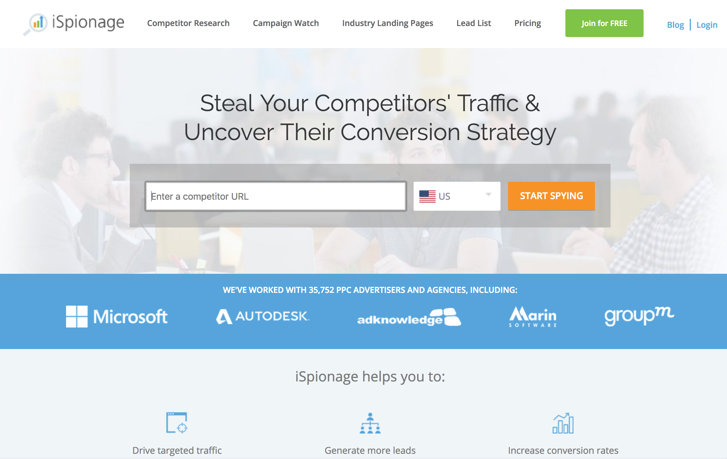

#62 – How to Use One Simple Questions to Make Sure Your Customers Are Happy
The Net Promoter Score (NPS), a real marketing research institution, was developed more than a decade ago and has been the metric du jour of corporate marketing departments since. Its sole purpose is to measure customer loyalty. The mechanics of an NPS survey is pretty straightforward. Your customers are asked the question, “How likely is it that you would recommend our company/product/service to a friend?” Then they are asked to provide a rating based on the 10-point scale. Some companies will charge you a hefty sum to send these surveys out to your customers, but you can use Wufoo (https://wufoo.com) in conjunction with SendWithUs (https://sendwithus.com) to start saving money while keeping informed of what your users think of your company.

Chapter Three – Scaling for Growth Hacks
Eventually, the acquisition channels that you so meticulously researched and worked with will ultimately become inefficient as more and more competitors enter the channel and drive up costs. Fortunately, every emerging channel presents a window of opportunity that will allow you to be able to acquire customers efficiently. Now, brand awareness needs to be a key focus, and you need to load as many leads into the top of the funnel so you can experience accelerated profit growth.

#63 – How to Get Serious with Your SEO Using Moz
So far, you've probably spent a lot of your marketing time and money on paid advertising channels that you can optimize to drive traffic to your site. Doing this has allowed you to establish scalable, predictable, and repeatable marketing channels. However, at some point, you'll need to scale back your paid traffic in favor of free organic traffic. This will require you to get more advanced and aggressive with your analytics and SEO data. When you're ready to get more serious about your SEO, you'll want to add Moz (https://moz.com) into your bag of tricks. Moz is a longtime leader in the SEO space and can help you establish a baseline for your performance and provide you with insight and quick SEO tips for your site.

#64 – How to Match Your Page Content with Your Offer
After spending a considerable amount of time developing your blog, your efforts have finally paid off. You now have a number of posts that drive significant amounts of traffic to your site. However, these might not be the highest-converting pages. Once a visitor has landed on your page, they typically don't have any incentive to stick around, and they end up moving on to the next thing that catches their eye. Usually, the next thing isn't on your site. To fix this, and keep users on your site, you need to maximize the return on your content assets by turning as many of your visitors into leads or subscribers. You need to determine which of your pages have the highest bounce rate, something you can track with Google Analytics, and find an incentive to provide visitors to those pages. Just make sure that your incentive matches the content of the post.

#65 – How to Grow Your Twitter Follower Count
When growing your Twitter followers with an automation tool, you need to think of your followers not as individual leads, but more like seeds being planted in soil. This is because you need to use a high velocity of following and unfollowing of twitter accounts to grow your following. You can use Tweepi (https://tweepi.com) to help you build your Twitter brand with the power of artificial intelligence. With a Tweepi account, the service will monitor Twitter for you to find the best tweets and users to engage with based on the parameters that you set.

#66 – How to Create Personal Content for Your Website
Context marketing refers to the personalizing a website's content based on the visitor's previous history of interacting with your start-up. Not just your site, not only your email campaign, not only your paid advertising but all of the marketing channels you use. For example, when a new visitor lands on your homepage and downloads a white paper and submits their details via a form page, they will end up seeing the same generic message that all the other first-time web visitors see. What if instead, that same visitor sees their name when they return to their site. This can be accomplished with ORBTR (https://orbiterproject.org) and its contextual marketing widget. With this type of personalization, your customers can’t help but be impressed with your business.

#67 – How to Know Which Metrics Are Critical to Measure

If you want to get huge results from your online store, then you have to know which KPIs are critical for you to measure. Out of all the crazy acronyms that you should be tracking, there is a small list of those that are instrumental to growing your business. Here are the metrics that you should be keeping a close eye on.

- Churn
- Contracted Monthly Recurring Revenue (CMRR)
- Cash
- Lifetime Profit per Customer (LPC)
- Customer Acquisition Cost Ratio
- Cost Per Acquisition

Knowing what each of these metrics means and their importance in growing your business will put you well ahead of the rest of the pack.

#68 – How to Use Zapier to Make Your Life Easier
Zapier (https://zapier.com) is a cool tech company that can connect one system to another to allow them to communicate. It moves information between your web apps automatically so that you can focus on your more important work. If you want one system to perform an action based on a trigger from another system, Zapier will let you create those automation rules. Knowing how to do this can save you a ton of time and allow you to open up new marketing doors.

#69 – How to Become a Thought Leader with Email Courses
Your customer isn't always ready to buy when you're ready to sell. If you can establish yourself as a thought leader, it will ensure that your brand remains at the top of your customer's minds when they are ready to buy. One easy and fairly inexpensive way to do this is to create an email course. Your email courses need to be focused on something that your customers are struggling with while ensuring that the topic sells your product. You also want to make sure that you are confident in teaching the subject. Create a series of six to seven emails that teach an issue and make sure each email in the series is loaded with CTAs. It is important that you try to match your content with the buyer stage that your customer is currently in.

#70 – How to Send Email to Users Who Haven’t Referred a Customer Yet
No matter how great your product or service is, there will be users that just won’t refer a friend, for whatever reason. Or, they might take such a long time to refer someone. You know there must be a way that you can get them to do so sooner. Luckily you can do this fairly easily. First, you need to have a way to track referral. Then you need to configure your transactional email app to send out an automated email if the user hasn’t referred someone after a certain amount of time. The goal is to automate the process so users who are on the fence will start to refer people.

#71 – How to Implement Automatic Trigger Based Emails
Automating your emails is easy to do. There are a ton of providers out there that promise the moon and then quickly take it away with their limitations and technical requirement. One company, Customer.io (https://customer.io) is different. Unlike other companies, they allow marketers to segment users on the fly and send automated emails to website visitors based on the pages they visited or the actions they take. While most email providers rely on segmentation on the back end, Customer.io lets you link messages to very specific front end actions, which makes sending automated emails based on different triggers super easy to accomplish.

#72 – How to Collaborate With Users on Product Development
If you even begin to entertain the idea of creating a new product, you need to find out if there is actual demand for it. This is where collaborating with your users can pay off. Even if you’re just looking to implement new features, it is important that you get your users involved by iterating a bare-bones prototype while getting constant input and feedback from your users. There are many prototyping tools available for you to choose from to help you along with this process. You can collaborate with users by running in-app surveys, or send out emails and encourage participation by your users. There is no better way to retain a customer than by having them help create your product and make them aware that their voice is being heard.

#73 – How to Hack Your Site pages for Increasing Organic Traffic
If you want to increase organic traffic, you'll need to get a role model or company that you can watch for inspiration and ideas. You can use BuzzSumo for research. When you find a company that you want to immolate, in terms of content, you'll want to start gathering all your topical content in one place. Then, start to update all of your previous blog posts on the topic to include prominent links to the site pages for increased organic traffic to both the new and the original post.

#74 – How to Track and Follow Up on Social Media Mentions
A lot of the challenge in growing your business is learning how to identify customers in the key moment when they're primed to make a decision. Unfortunately, this can be difficult to do. Search engine marketing is so explosive because search is the best-known way to determine what an online buyer's intent is. Social media offers the promise to catch customers in that moment. But how can you keep track of all the mentions through all the different social media sites? With Mention (https://mention.com) you can. All you need to do is create an account, set up the mentions you want to track, which can include your brand name, competitors, keywords, queries you want to track, etc. Then, anytime one of these parameters is mention on social media you'll get notified and follow-up directly through the dashboard.

#75 – How to Make HubSpot Your Marketing Ground Zero
At some point, you will have enough consistent, predictable revenue growth that you'll need to improve your marketing stack. The systems and processes that you originally put in place will have limitations and won’t be able to perform to the degree that you need it to. This is when HubSpot (https://hubspot.com) can benefit you. HubSpot is a marketing platform that lets you build your inbound marketing functions into one platform. With HubSpot, you can have all your blogging, SEO, CRM, landing pages, automation, calls to action and analytics, all in one place.

#76 – How to Have a Personal Assistant Without Breaking Your Budget
At some point as a business owner, you’ll become so busy that you’ll need to bring someone on just to help you stay organized, keep you focused and productive, and help you handle tasks that pull your focus from the important, growth tasks your business needs. This is where it can be extremely beneficial to hire a personal assistant. Unfortunately, this can get expensive. Fortunately, you don’t have to hire someone to work for you for 40 hours a week. Instead, you can use a service like Fancy Hands (https://fancyhands.com) and subscribe to a monthly number of requests, which you can use to complete personal tasks, like scheduling meetings, managing travel itineraries, or for research. Or, you can hire a virtual personal assistant through an online freelancing site like Upwork (https://upwork.com) or Freelancer (https://freelancer.com).

#77 – How to Outsource Your Market Research
Another task that you can outsource is your market research with overseas assistants. This way you can assign a task before you head home for the day, and have it completed by the time you wake up. The key to efficiently managing your overseas service provider is communication. You will need to be able to communicate very simply, clearly, and literally. Make sure you provide them with examples and templates for what you expect. When you put the effort in at the beginning, you'll save all the hassle of unnecessary re-work. While many companies can help you set this up Acelerar (https://acelerartec.com) is a good place to start.

#78 – How to Create Your Own Growth Hacking Hub with Pocket
If you follow the advice in this book, you’ll start spending a lot of time learning. You’ll read blog posts, articles, websites, and books to stay on the cutting edge of marketing. A great way to keep all this content organized and available to read is by using Pocket (https://getpocket.com), as your article reader. Pocket lets you bookmark and categorizes articles for future reading. The offline features create a growth hack learning hub that you can take and read anywhere.

#79 – How to Keep in Touch with Your Network Through LinkedIn Connections
Keeping in touch with your network is extremely important because you don't want to be seen as someone who only reaches out when they need something. When you sign up with LinkedIn Connections, you'll receive an email every time there's a new story about someone in your network, making it much easier for you to keep tabs and send a congratulations email when they've been mentioned for a new product or promotion.

Conclusion
When it comes to getting huge results for your Internet business, it’s important to remember that you will always have something new to learn.

These 79 tips and actions steps will get you started on the road to success, but you’ll want to continue to keep your eye on the pulse of new marketing trends and ways to promote and grow your business.

