The 5-Minute Guide to Creating an Online Business Around Your Lifestyle

- SPECIAL REPORT -

By [YOUR NAME]
[URL]

Many of those who start off with the intention of creating an online business get stuck in the day to day details of running it. SEO, PPC, marketing, networking, site optimization, budgeting, delivering value, scheduling content, improving the product, scaling the business, it all takes a considerable amount of time and resources. This is why it is essential to create an online business around your unique lifestyle. One of the biggest advantages of online businesses is that you can manage resources in such a way that you have more free time to do what you really want.

Get Organized

Organization is important in all areas of life. Without being organized, it is nearly impossible to deliver value to customers. The basic requirements of being organized in terms of an online business include -

- Taxation
- Branding
- Website development
- SEO
- Sales
- Marketing
- Automation tools
- Employees and freelancers
- Customer service
- Scaling up the business
- Product/service creation and delivery
- Delivering more value to the customer

Within each of these broad categories are a large number of subcategories to choose from. You need to stay on top of it all as best you can. In a corporation, you would typically have a clearly defined role and nearly everything else would be taken care of. But as a solopreneur, you need to do everything yourself. There are tools available that can help you to manage all of the moving parts of an online business. Some of the better and more well-known tools include -

- Evernote - Excellent for personal note organization across devices.
- MailChimp - For managing email marketing campaigns.
- Buffer - For social media management across a variety of platforms.
- Slack - User-friendly communication tool.
- Hubspot - Inbound marketing platform with a huge range of features.
- Google Calendar - Scheduling appointments and events.
- Intercom - An easy way to interact with customers.

Personal organization is extremely important and you need to be disciplined in terms of when you work. You will need to get into a routine in order to deliver high-quality products and services to customers. After a year or two of organization and consistency, you can then take your foot off the pedal a little. You can use a tool like Microsoft Excel to create a table to keep track of all the different aspects of your business.

You also need to master your own psychology and get organized across all areas of life before you really set yourself up for success. The business is not entirely separate from your personal life, though others might try to tell you this. It is rare to be extremely unhappy and disorganized in one area of life and be a huge success in the other. Be organized, systematic, and detailed across all possible dimensions.

Take Things Slowly

Eventually, the end goal is to be able to work as little as possible while still generating a significant revenue stream. But this does take time. And not only does it take time, but the results are mainly seen towards the end of the campaign. For example, you could spend a year setting up your own small business with little or no profits. But by year two and three, your profits increase. By year 5 the business will likely turn an exceptional profit provided you have paid attention to what works.

Take things slowly, track what works, and optimize as you move along. It might appear at first glance that things are not appearing as quickly as you expect. You will run into obstacles and there will be unexpected things that you did not foresee. But this is all perfectly natural. Every business owner or entrepreneur runs into these difficulties.

You must learn to be patient with yourself. You can’t work all the time and you only have a finite amount of energy reserves available. In all industries, you learn to leverage other resources as you go along so you get maximum return on the effort that you invest. This always takes time. Part of taking things slowly is learning to take regular breaks and frequent holidays. At least in the beginning, you will be working something akin to a 9 - 5. But you should not work more. The fact of the matter is that people who work overtime and stress themselves out deliver sloppy work. They don’t think clearly, and they frequently make mistakes.

Get Creative

The dominant trait of the online industry is innovation and creativity. There is a constant stream of digital products coming online with updates that are replacing old versions. New models and systems frequently emerge. The advantages of this are that you can use all of these new technologies to find out what works for you and make your business run as smoothly as possible. There is a wide range of automation tools that you can use to streamline projects such as social media management or search engine optimization. There are freelancers for hire who can complete all manner of jobs and tasks that you need to get done swiftly. A nearly infinite amount of digital marketing techniques is available that you can use to drive traffic to your business.

The point of all this is that the online industry is a playground of creativity. There are so many ways to optimize your business. What’s even better is that using your creativity to build a better standard of living is actually fun. Or at least, it can and should be fun for those in the right mindset. All great online innovators such as Neil Patel use their creativity to constantly innovate. Innovation is also what is done by the most successful tech firms such as Facebook, Google, and Amazon. They are constantly changing and adapting.

Obviously, you are not currently running a multi-million-dollar company. But you can optimize the same way that these companies do on a smaller scale using some creative acumen. A virtual assistant can be hired for less than $5 per hour to complete tasks that you don’t like to do. You can brainstorm ways to innovate with colleagues.

Not only is creativity fun and essential for a healthy lifestyle, but it is also critical for success. Studies have indicated that startups that change their business model once or twice are far more successful compared to startups that stick to the same one. There are always ways to optimize and innovate. Make sure to take advantage and don’t be afraid to mix things up.

Make Sure You Enjoy It

Too many people are taking to online business simply for the purpose of making money. It is true that online businesses offer far more opportunities in comparison to other models. But you will need to pick something you are really passionate about and that you love to research. Choosing something that you don’t really enjoy is a quick route to failure. But even within your job, there will be things that you love to do and things that you hate. Over time, you can build a system where you get others to do the jobs that you hate, which could be advertising and web development, and focus on what you love to do, which could be building the core product and making it better.

When you are passionate about what you do, it shows. The audience will love you for it. You will be more enthusiastic about responding to posts and comments and will genuinely want to assist your customers. The type of audience you have will be long-term followers because they will like you for who you are, which will show up in the quality of your work.

Needless to say, you must choose something that you like doing, and stick with it consistently. The other tasks can get you down but all of the other stuff can be managed once you are really passionate about the core business model. If you are not enjoying the business anymore, it can simply be a sign that you need to change things up a little. But you can actually follow a golden rule of thumb. Simply switch your focus back to what you like to do and hire somebody else to get the menial tasks done. While this advice might sound flippant, the importance of focusing on what you love to do cannot be underestimated. Not only will you feel more fulfilled after doing so, but it will ultimately deliver a better return on investment. There are others who love doing the things that you hate and you should find them and employ them as necessary. You are not ‘extracting the value’ or anything like that. You are entering into a mutually beneficial contract, and both parties will be much better off for the transaction.

Network with Likeminded Individuals

People who love what they do and have built an online business around their lifestyle have a completely different mindset compared to corporate employees. And it shows. Generally, these people will be more positive and happier, as there are more opportunities for such people to go where they want and to do as they please. The same cannot be said for those climbing the corporate ladder. Even if they do earn a significant wage, it is a very linear process. Their wage is fixed, and they are often not able to do anything to increase it. They are also stuck in one location and have to work the standard workweek. In short, they have fewer opportunities available to them.

But there is a wide network of freelancers and solopreneurs and stay at home parents who are trying to emulate the freedom mindset. Try to establish relationships with people who are positive and uplifting and believe that life contains infinite possibilities. It will rub off and you will feel inspired.

You can figure out networking opportunities in your local area and find innovative ways to expand a small online operation. There are millions of freelancers and stay at home parents who should be networking with each other, but for some reason, this has not taken off as strongly as it should have. On a practical level, this networking will have multiple advantages. You can leverage the strengths of each other to build a stronger foundation.

Always Keep the End in Mind

This is arguably one of the most pivotal steps in creating an online business around your lifestyle. All people, not just those trying to create an online business, get stuck in a rut. They keep doing the same things every single day because it's just a habit. Without a clear goal and vision of what they want to achieve, they can never change. This is why you need to always keep an eye on the life of your dreams. Write down and review what you want on a regular basis, and try to visualize what it will be like when it arrives. If you are not crystal clear about what you want and actively focusing upon it, you will not get anywhere. Write out a list of the most important items that you want to achieve in terms of -

- Financial goals
- Work/play balance
- Relationship goals
- Health and fitness
- Spirituality

You don’t need to establish a time horizon for these goals, as this can sometimes hinder the time it takes to achieve them. Just focus on them every day and review them. If you don’t do this, you are guaranteed to quickly run into a brick wall. With the sheer amount of work that needs to be done, you can easily be worn down by the daily chores and struggles.

The more you can focus on what you really want and the life that you really want to have, the quicker it will arrive. A part of this is in developing a healthy psychology of never compromising on your goals and dreams. All of the best entrepreneurs refuse to let the outside environment get the better of them. They know what they want and they go for it at all costs. You should consider taking on this mentality if you really want to succeed in creating a business around your lifestyle, and not the other way around.

TOP RECOMMENDED GUIDE:

FREEDOM ONLINE BUSINESS: How To Create An Online Business Around Your Lifestyle
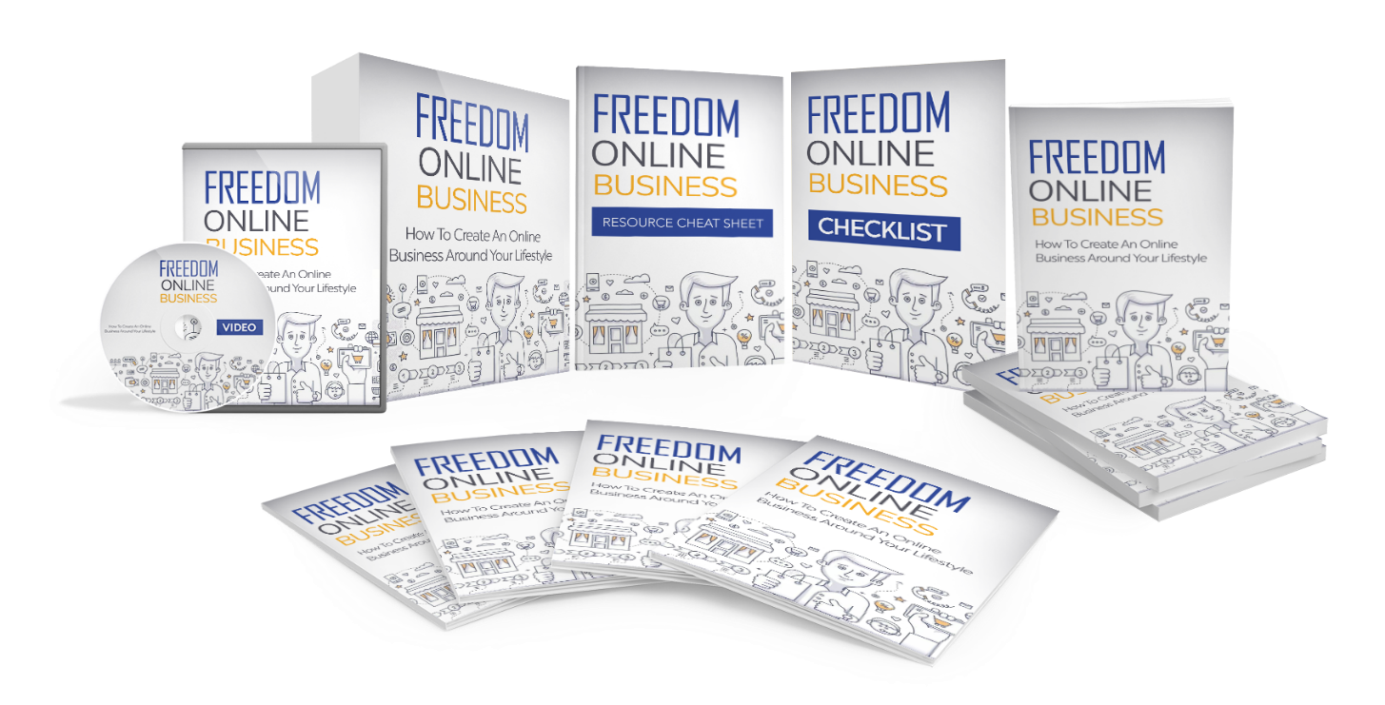

Find Out The Exact Steps And Techniques!


>> Click Here To Get Your Copy <<

